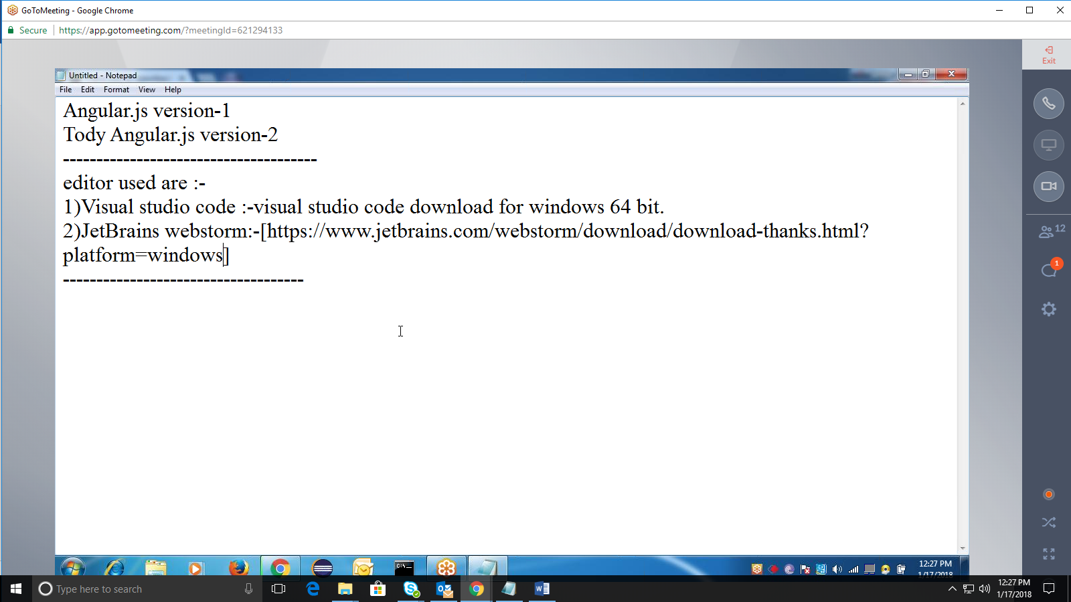

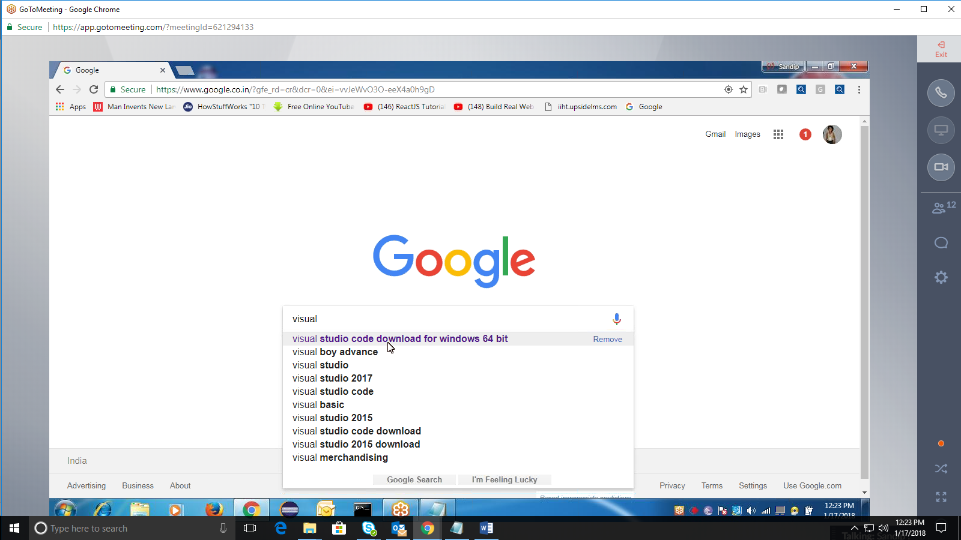

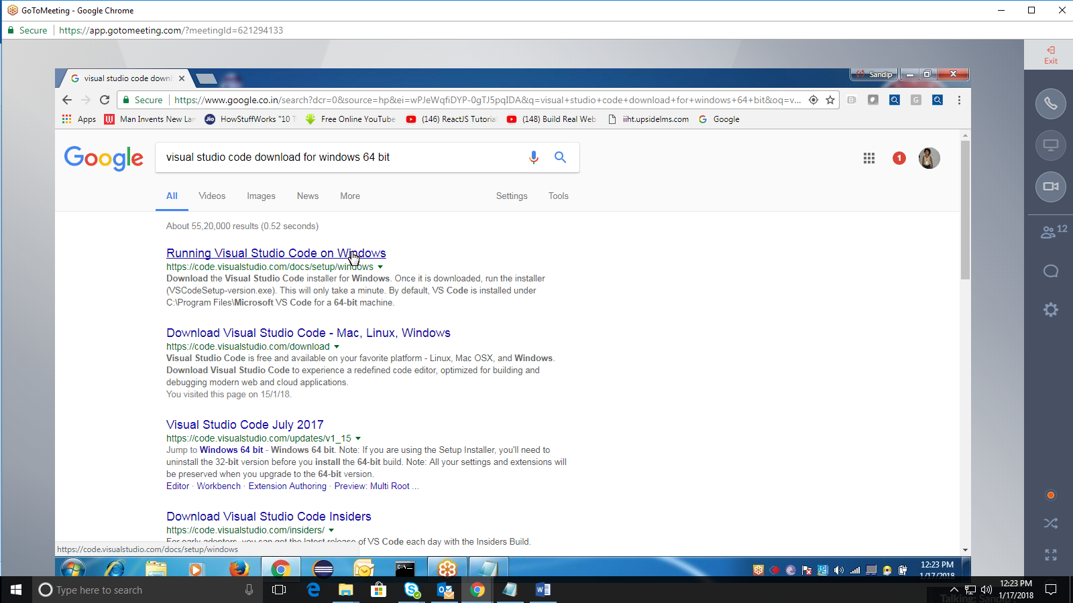

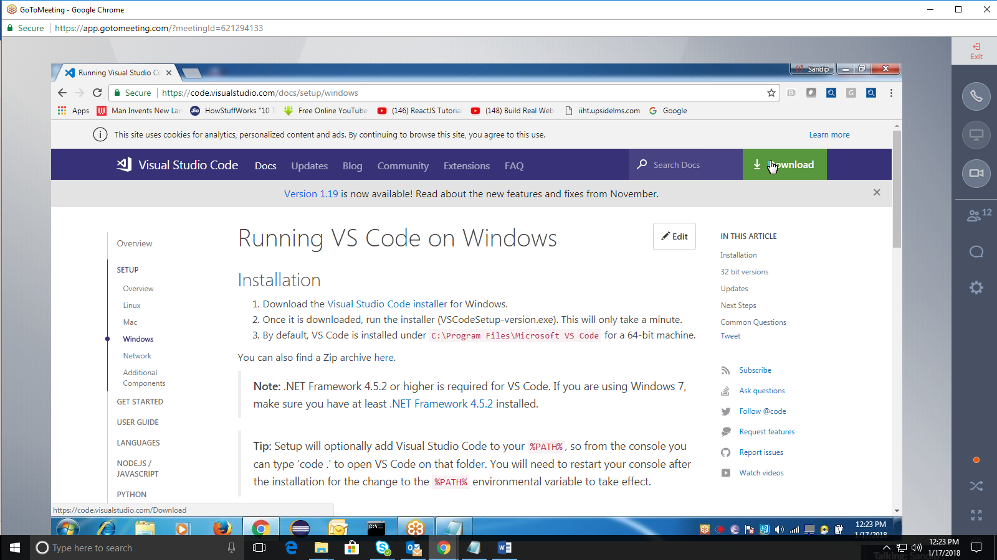

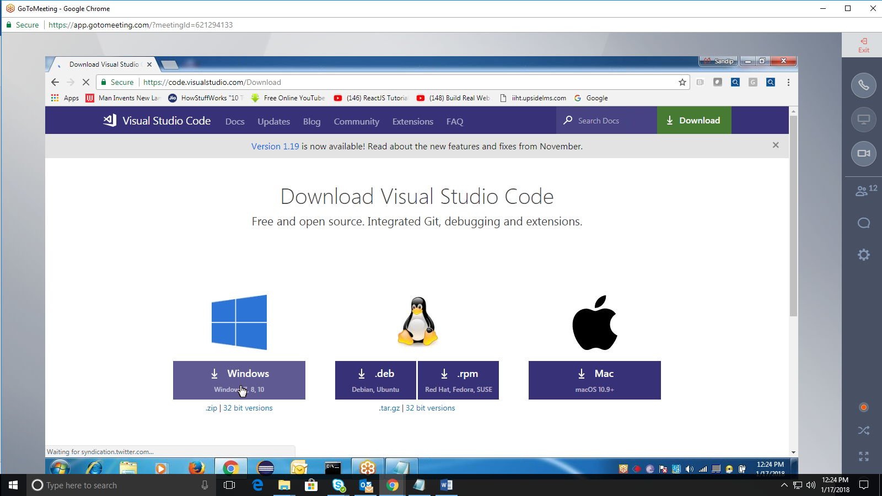

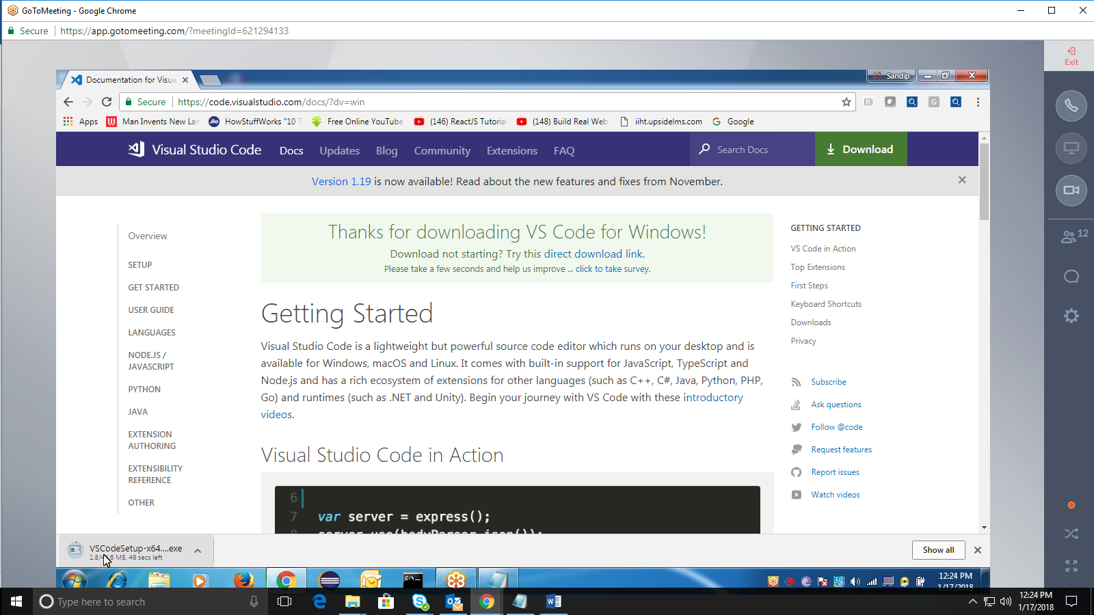

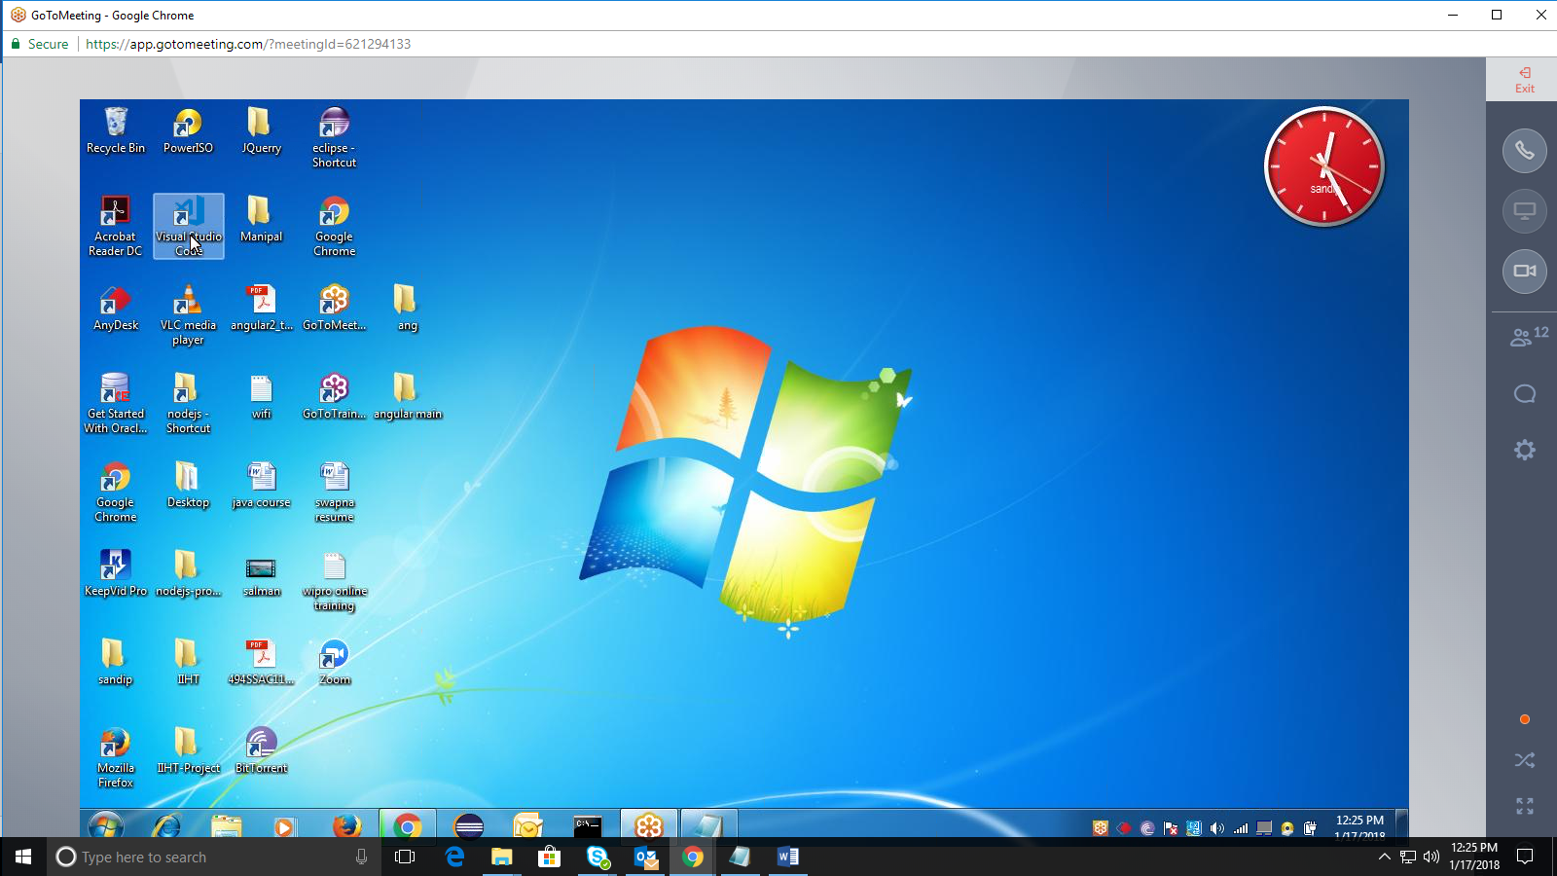

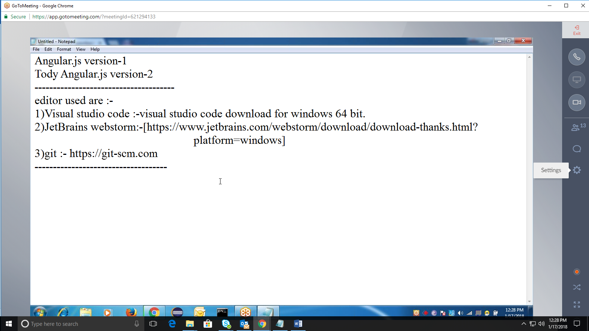

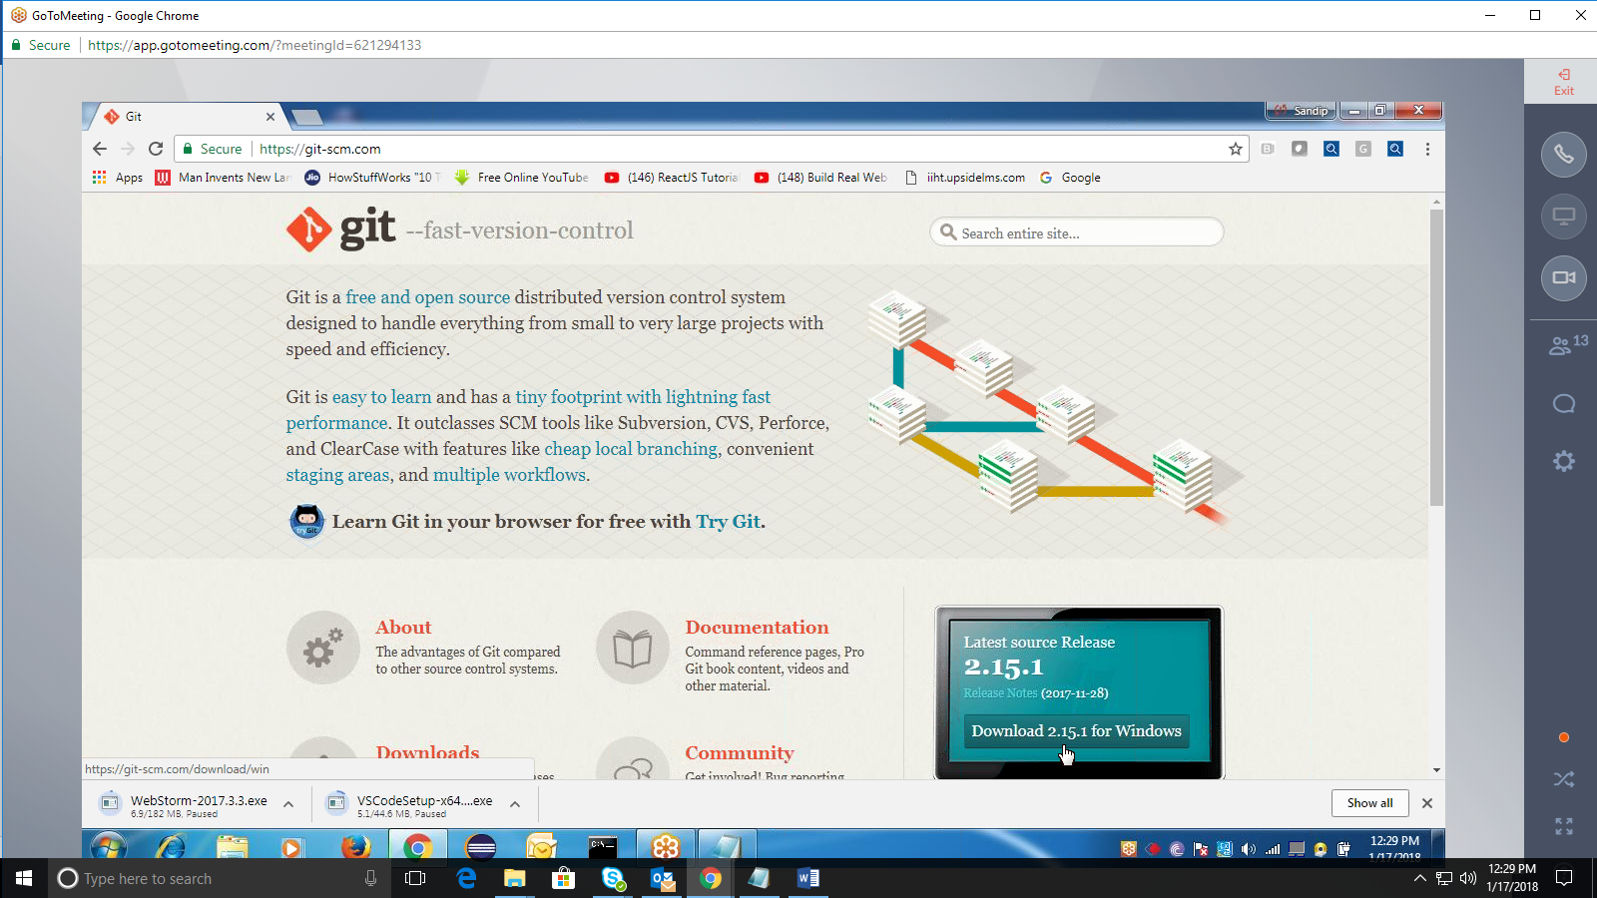

1)Visual studio code :-visual studio code download for windows 64 bit.  
2)JetBrains webstorm:-[<https://www.jetbrains.com/webstorm/download/download-thanks.html?>platform=windows]  
3)git :- [https://git-scm.com](https://git-scm.com/)

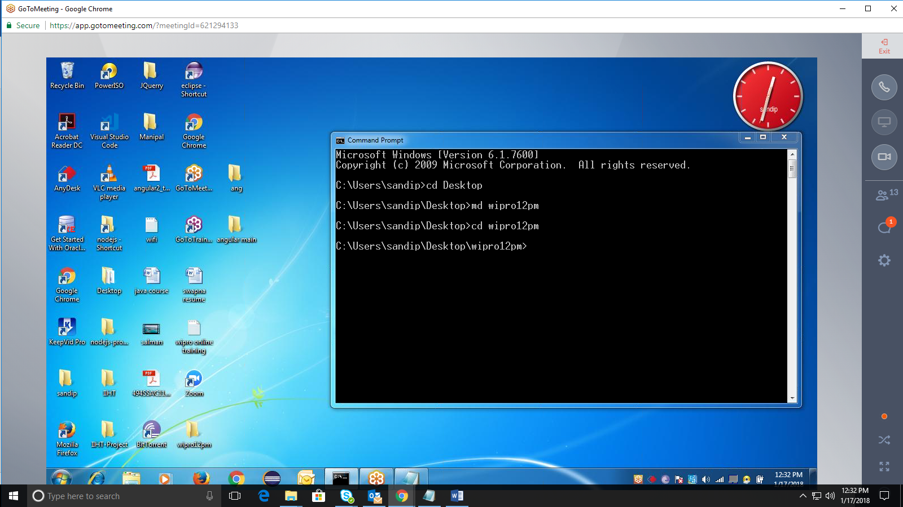

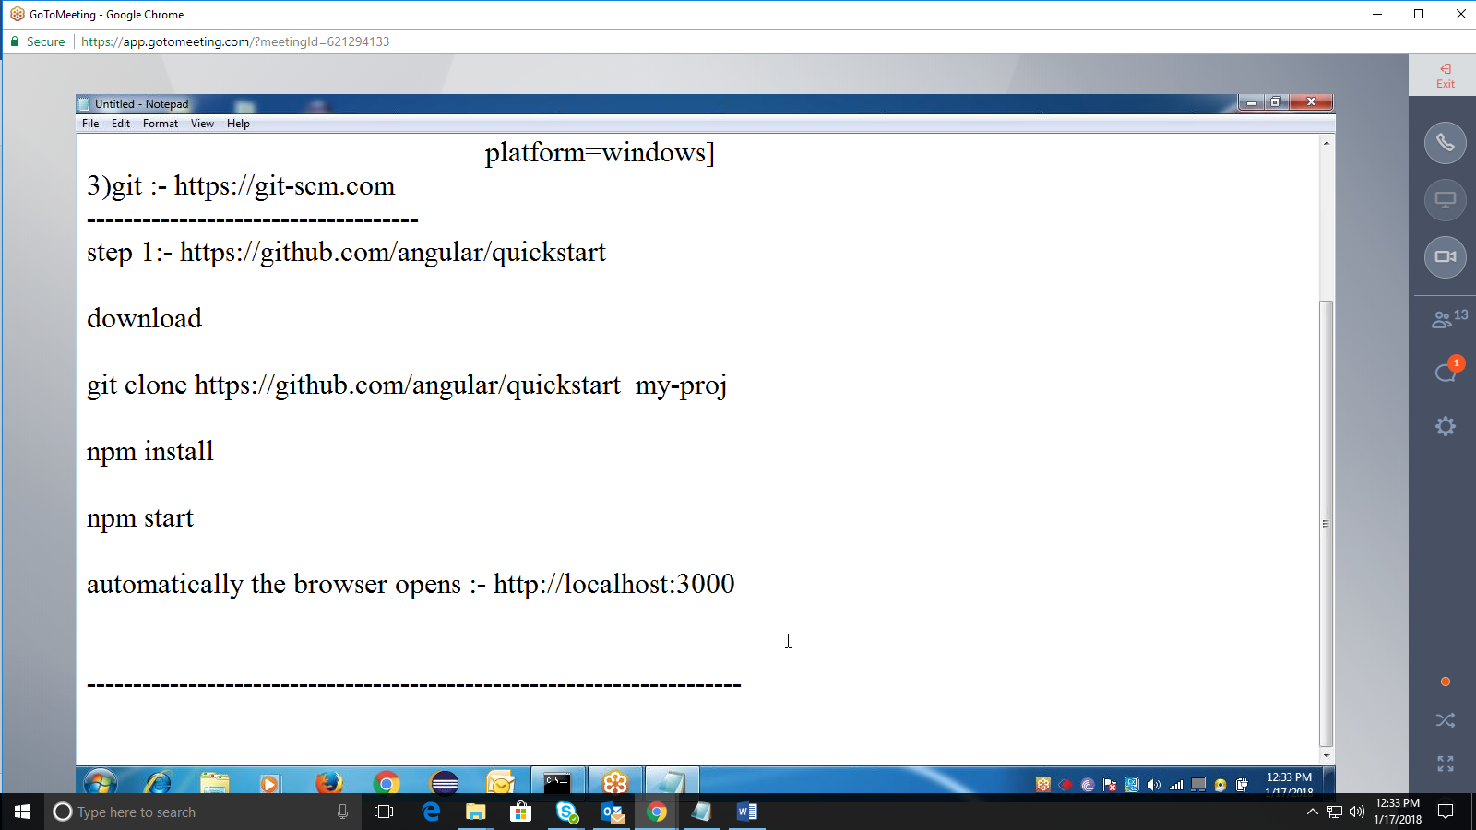

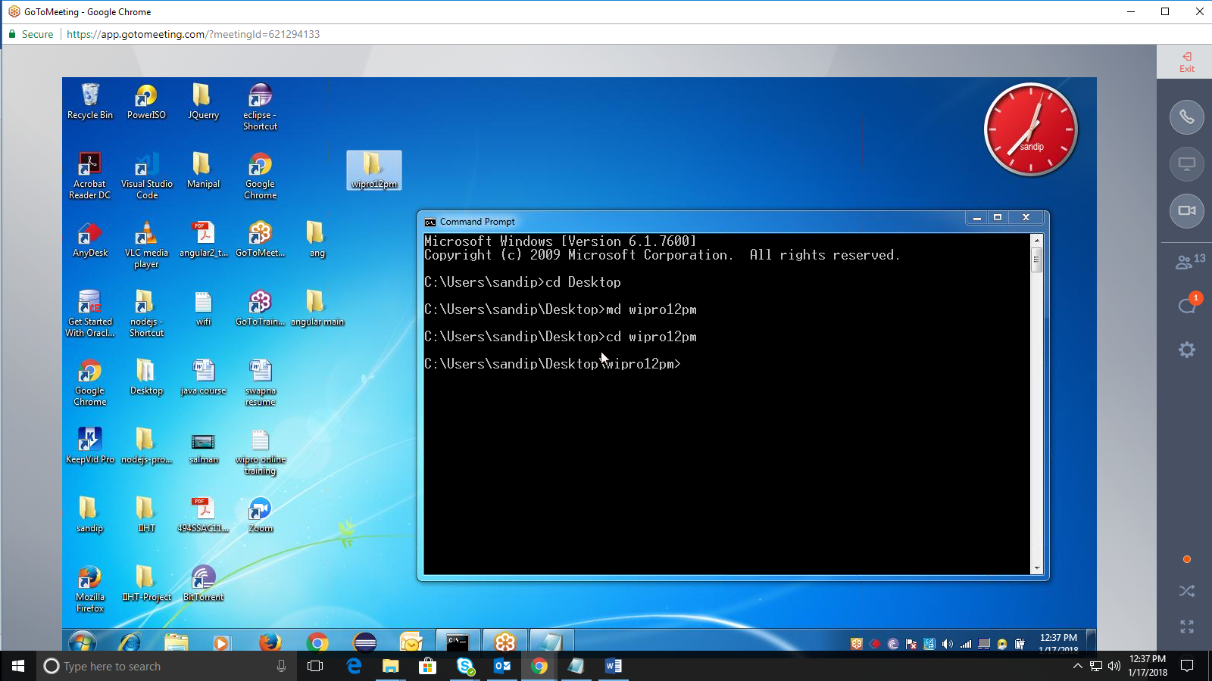

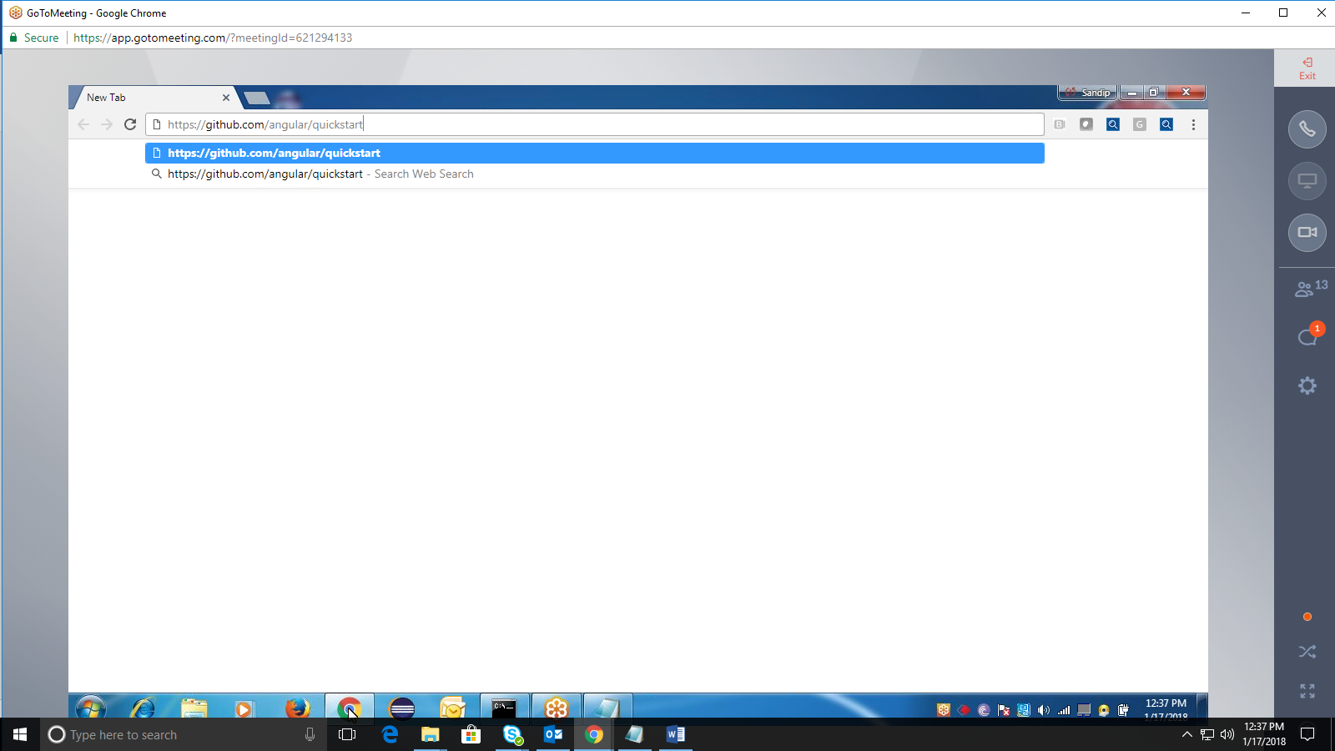

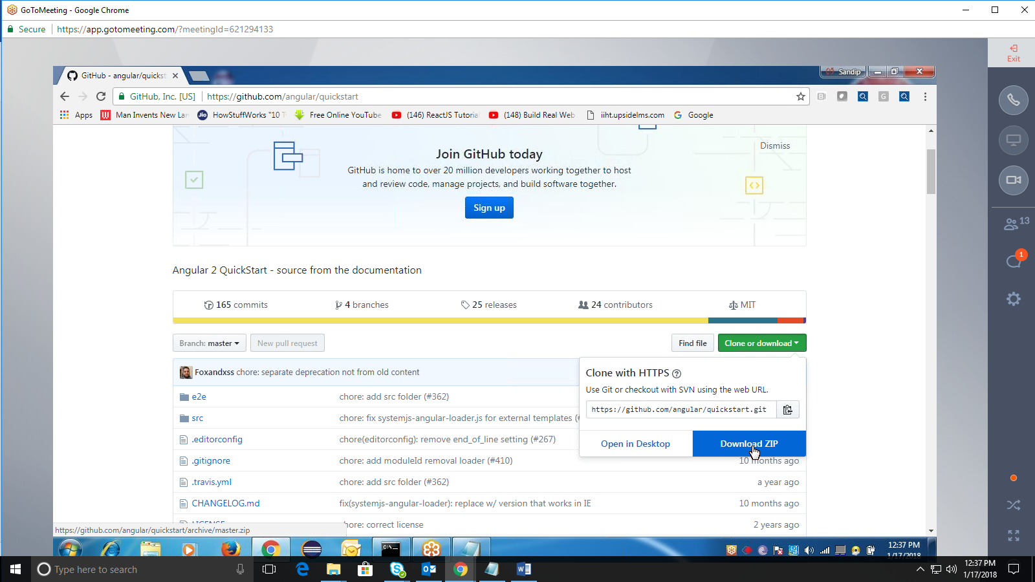

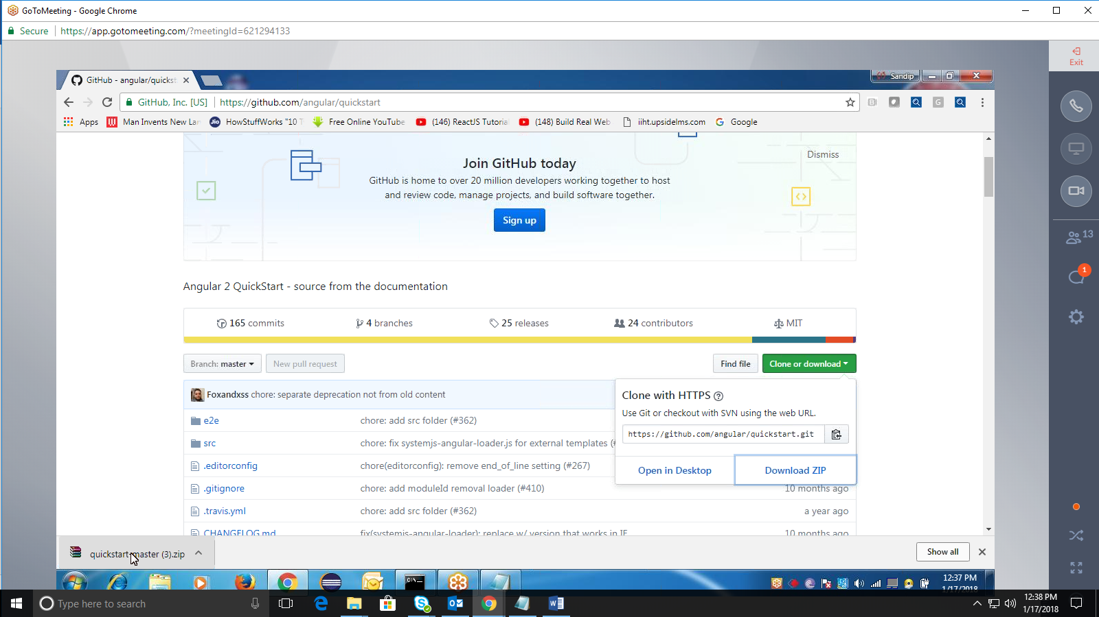

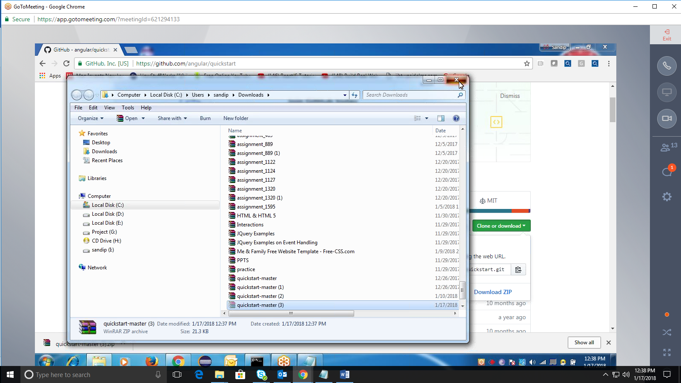

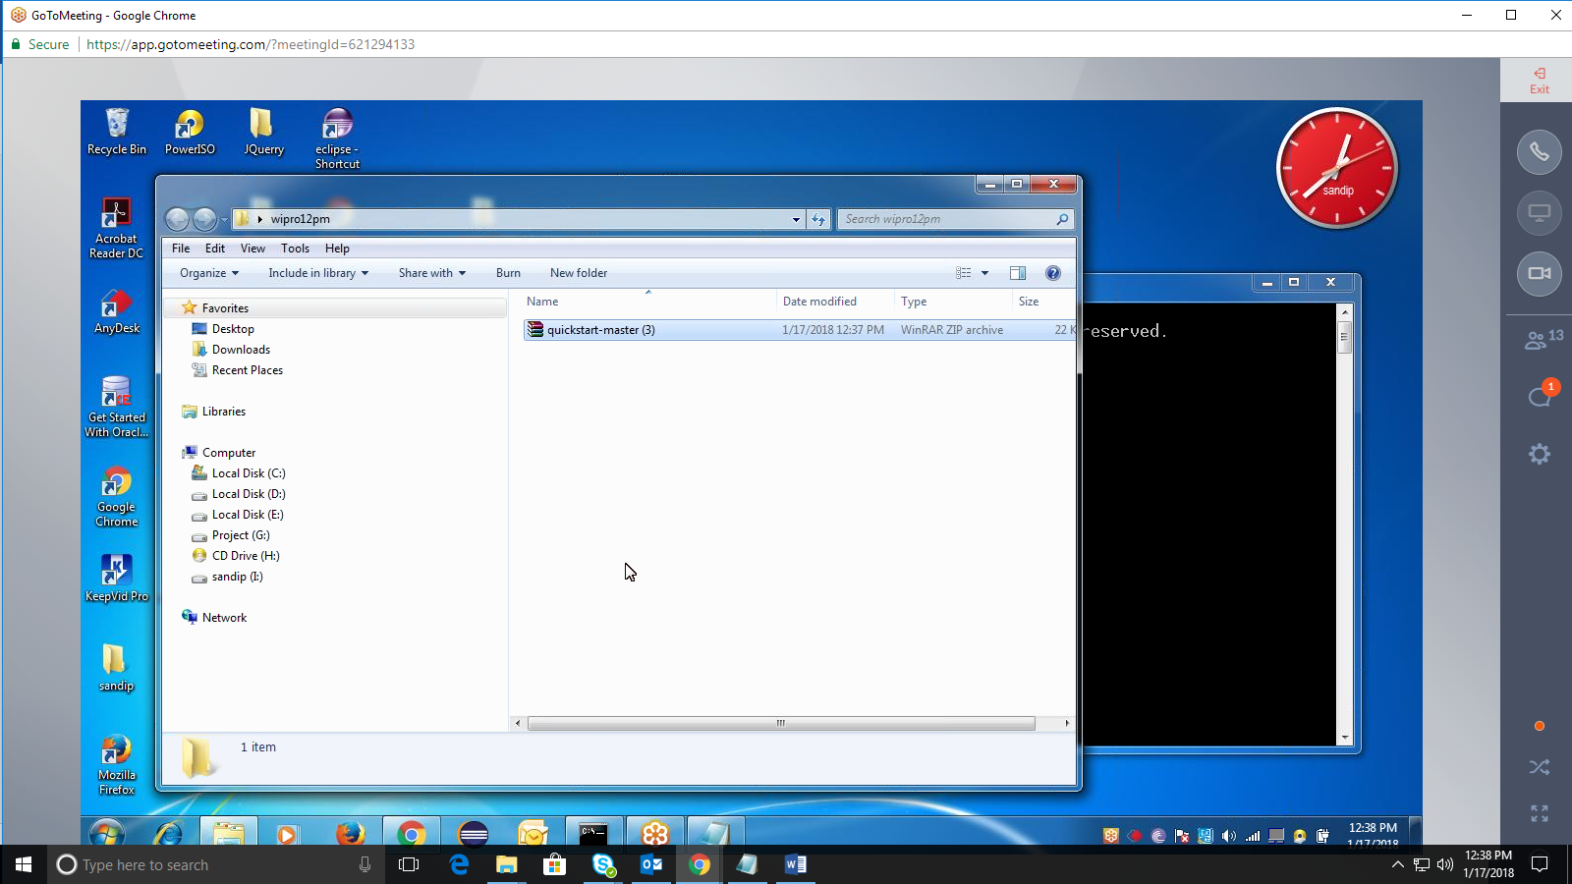

Extract here

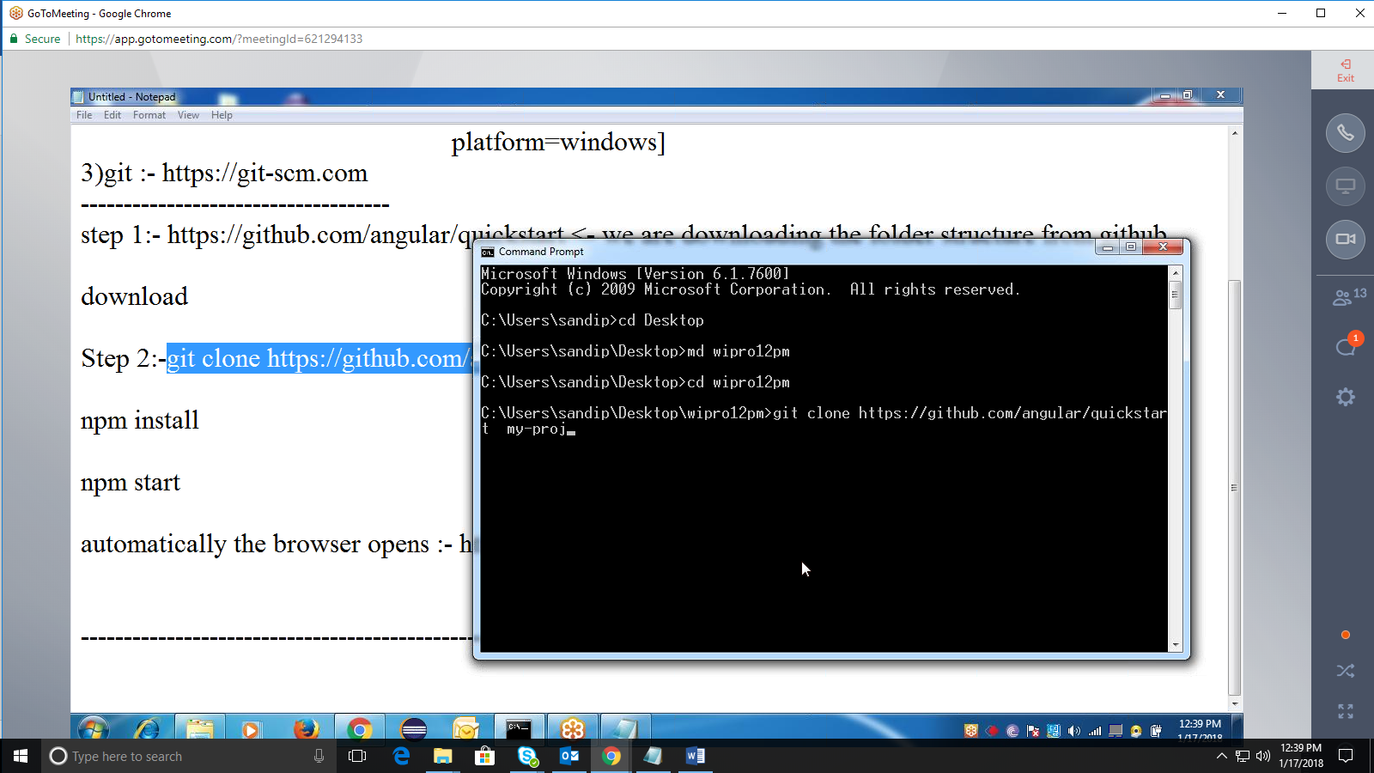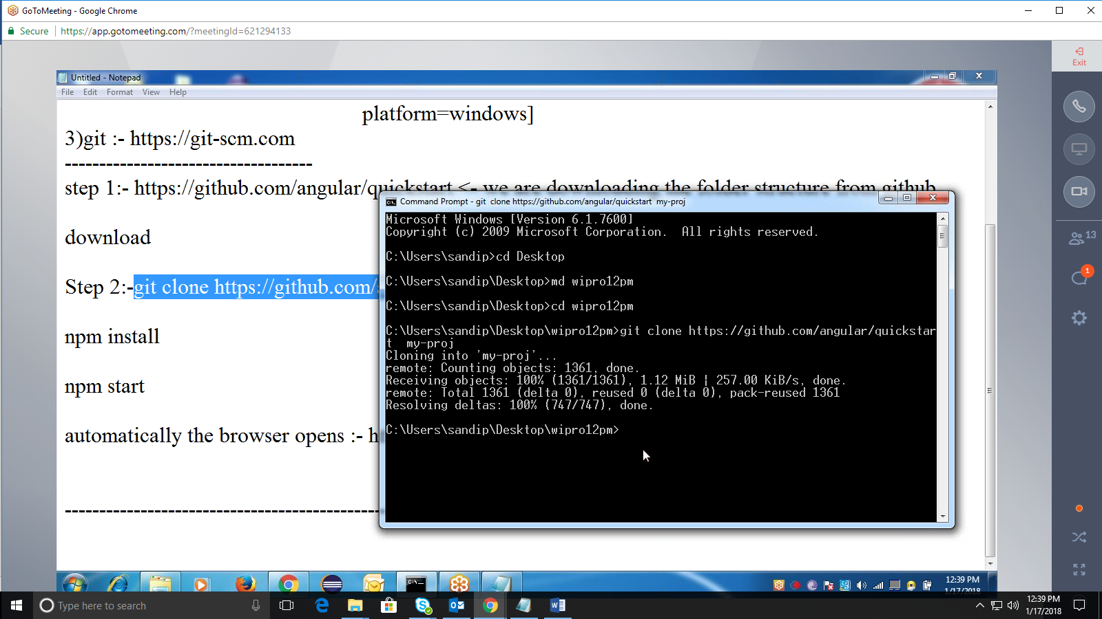

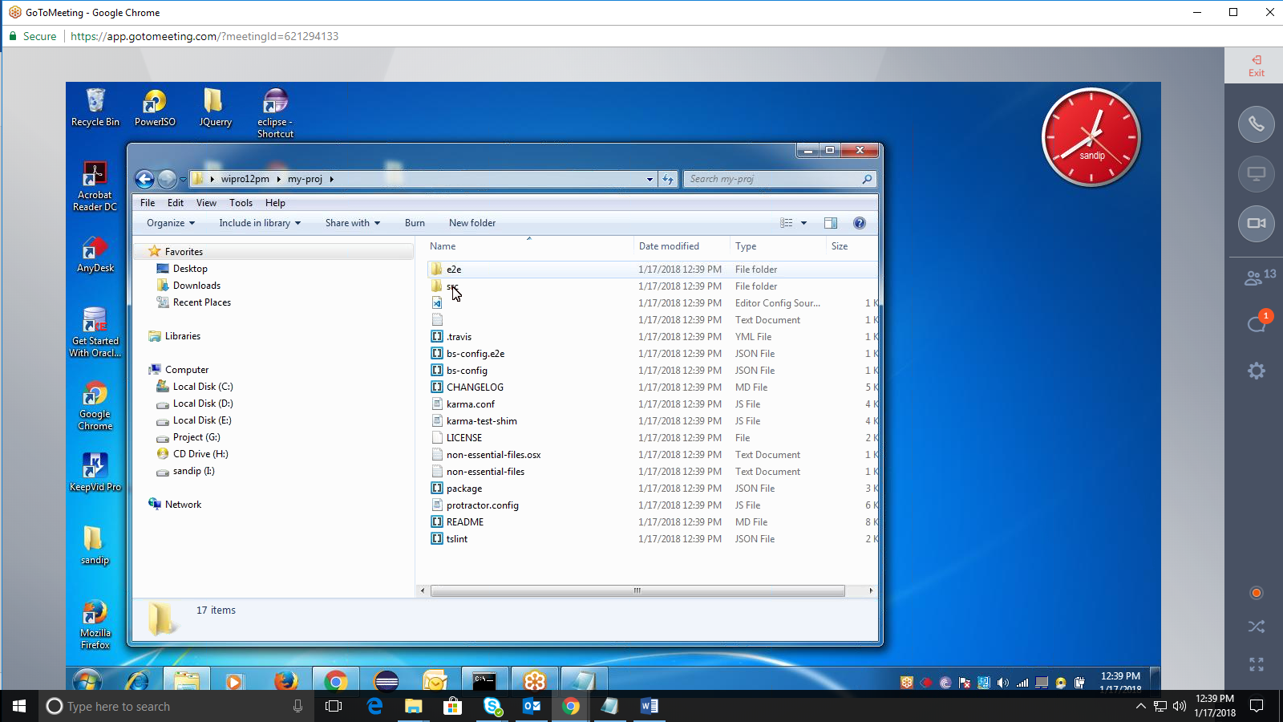

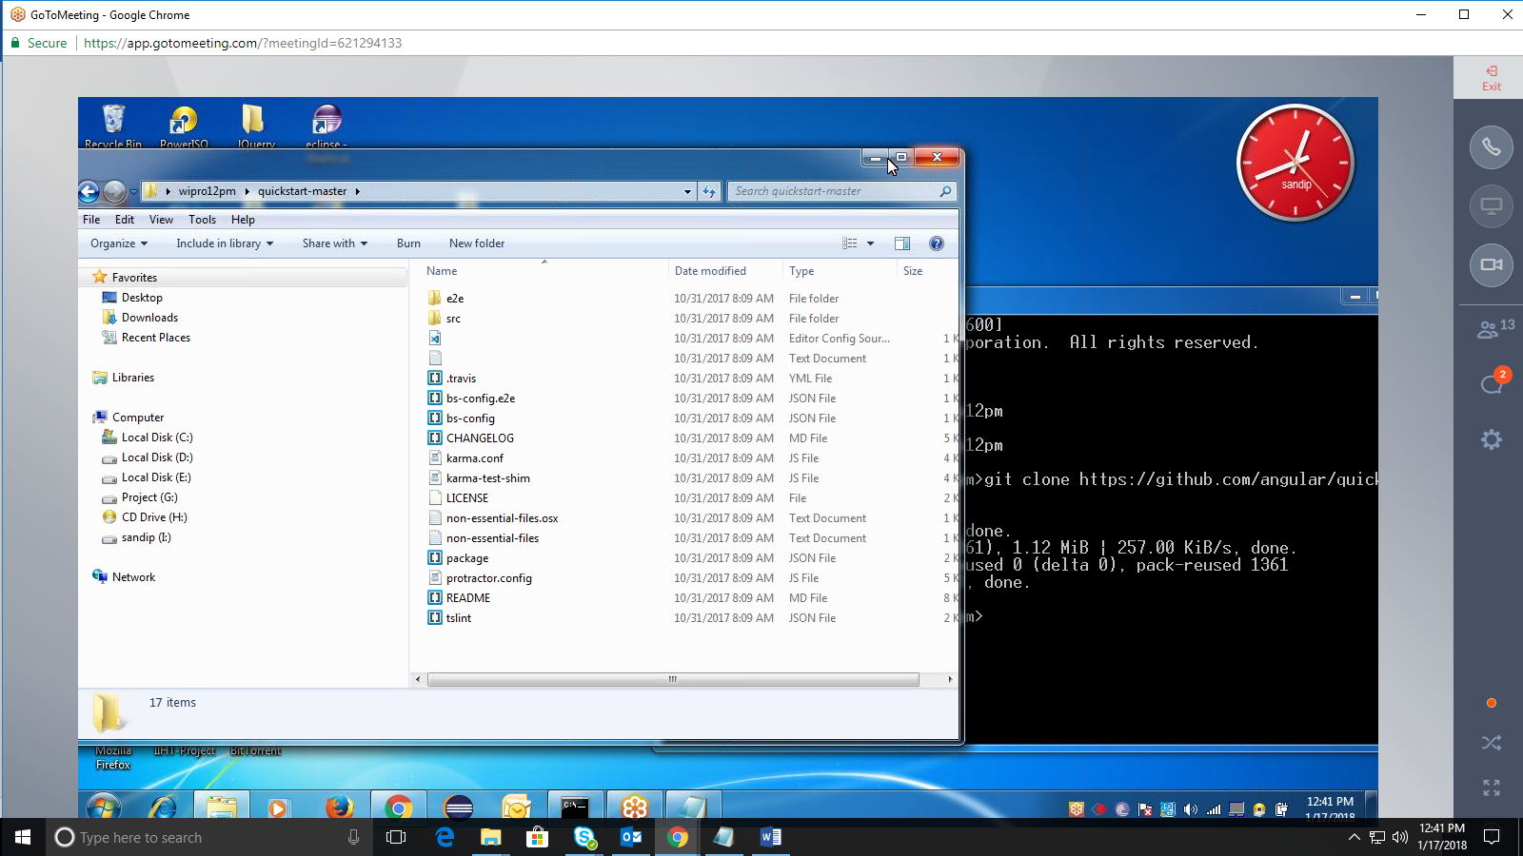

**Summary of Installation process:**

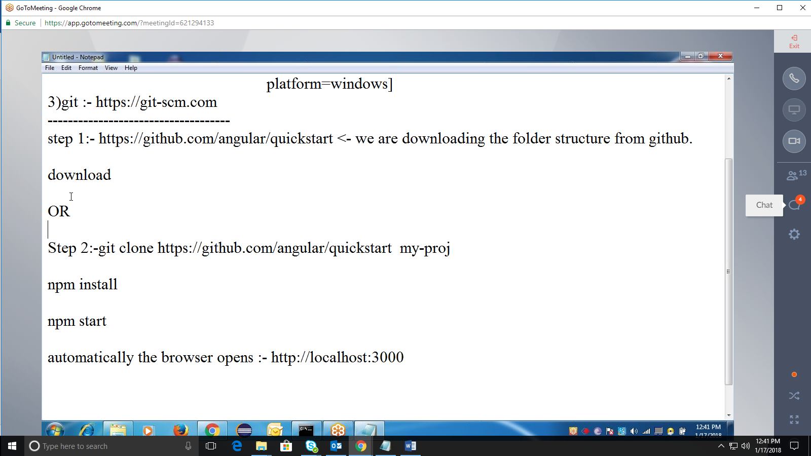

step 1:- <https://github.com/angular/quickstart> <- we are downloading the folder structure from github.

Download (from browser)

OR

Step 2:-git clone <https://github.com/angular/quickstart> my-proj (from command prompt)

Step 3:- npm install

ssetp 4:- npm start

automatically the browser opens :- [http://localhost:3000](http://localhost:3000/)

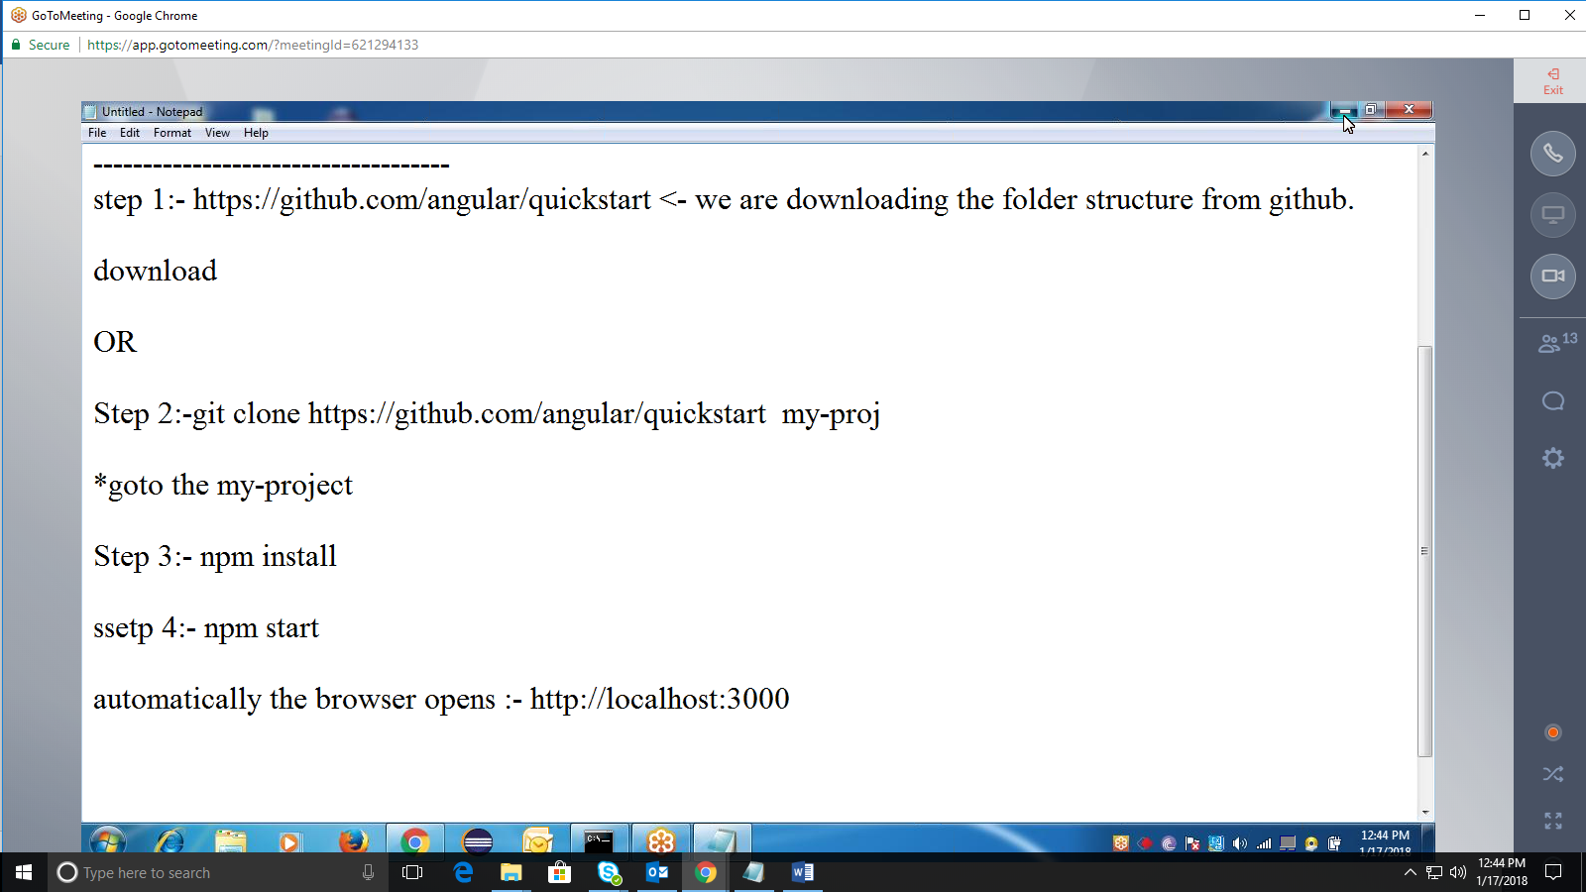

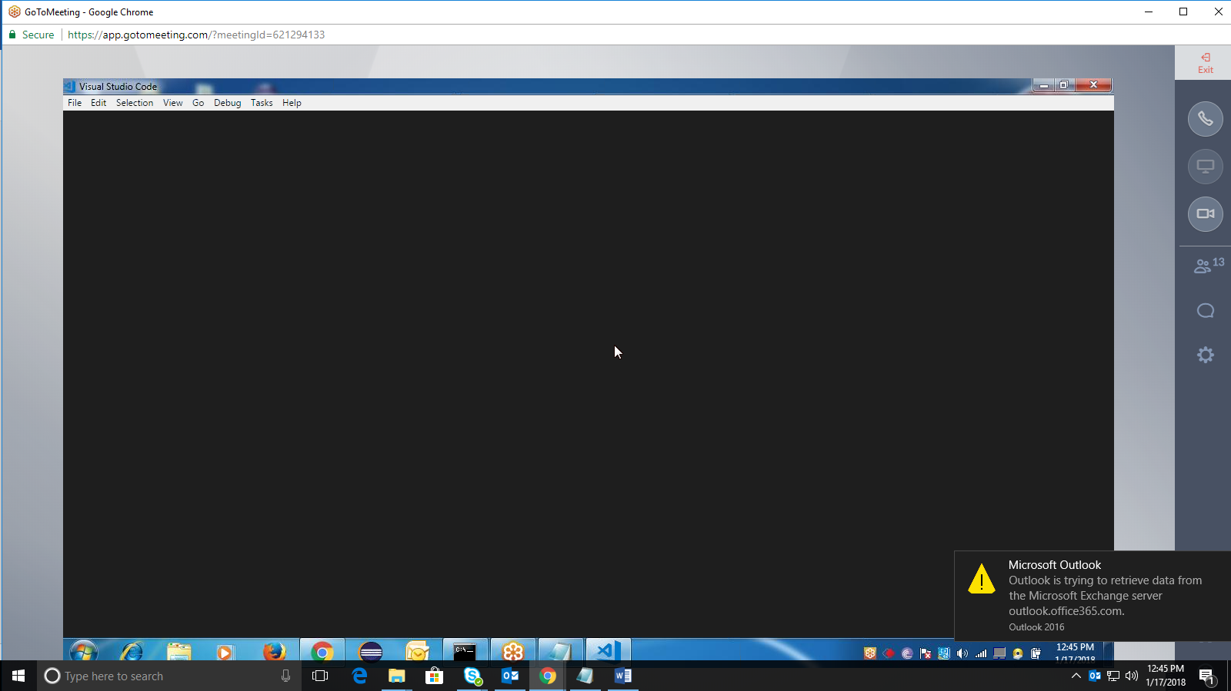

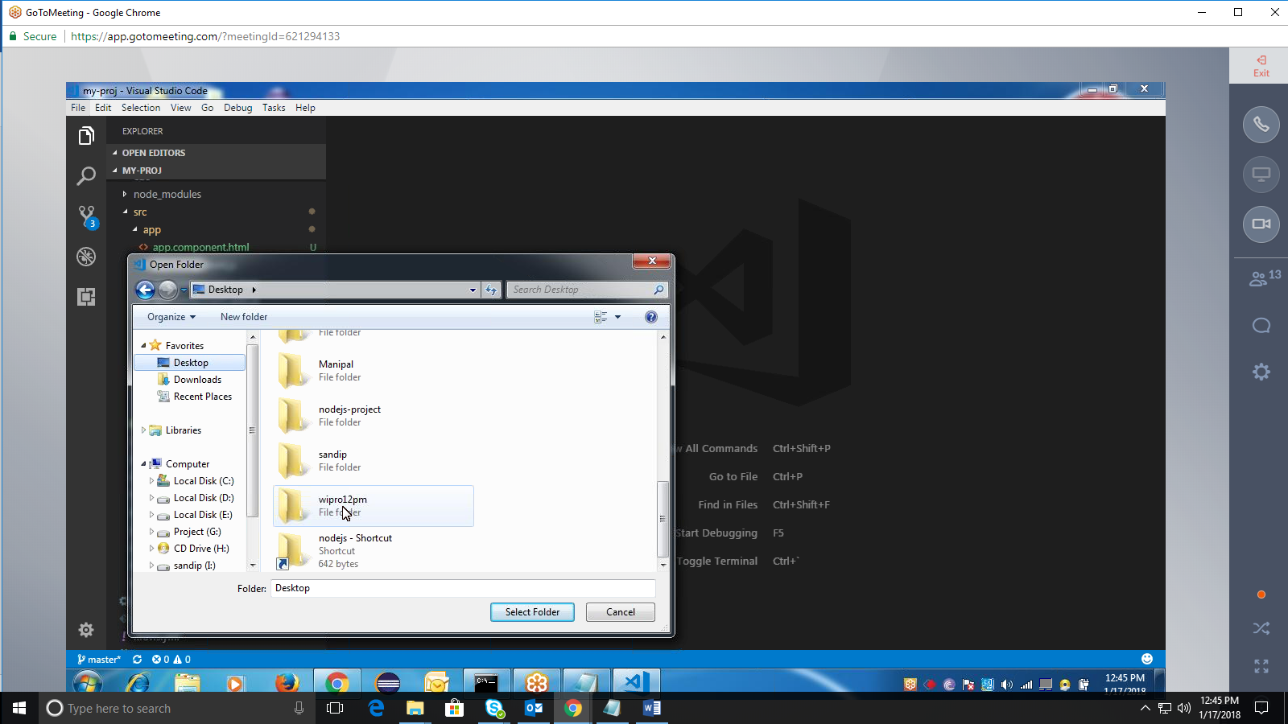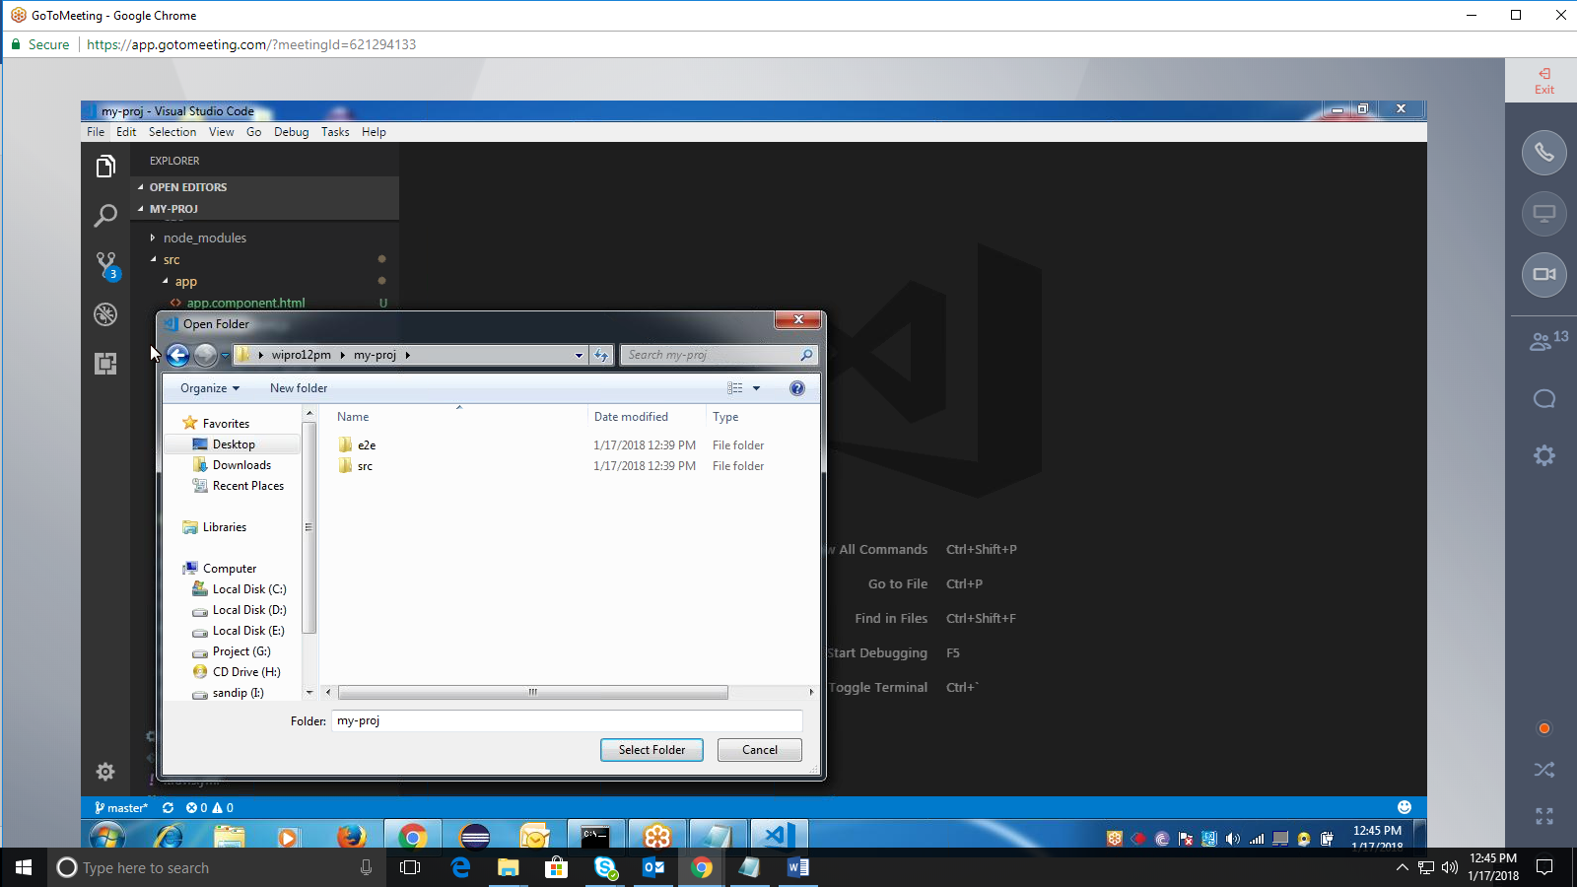

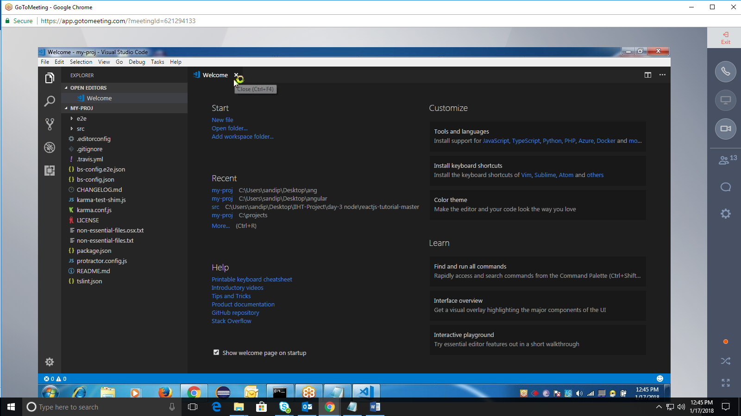

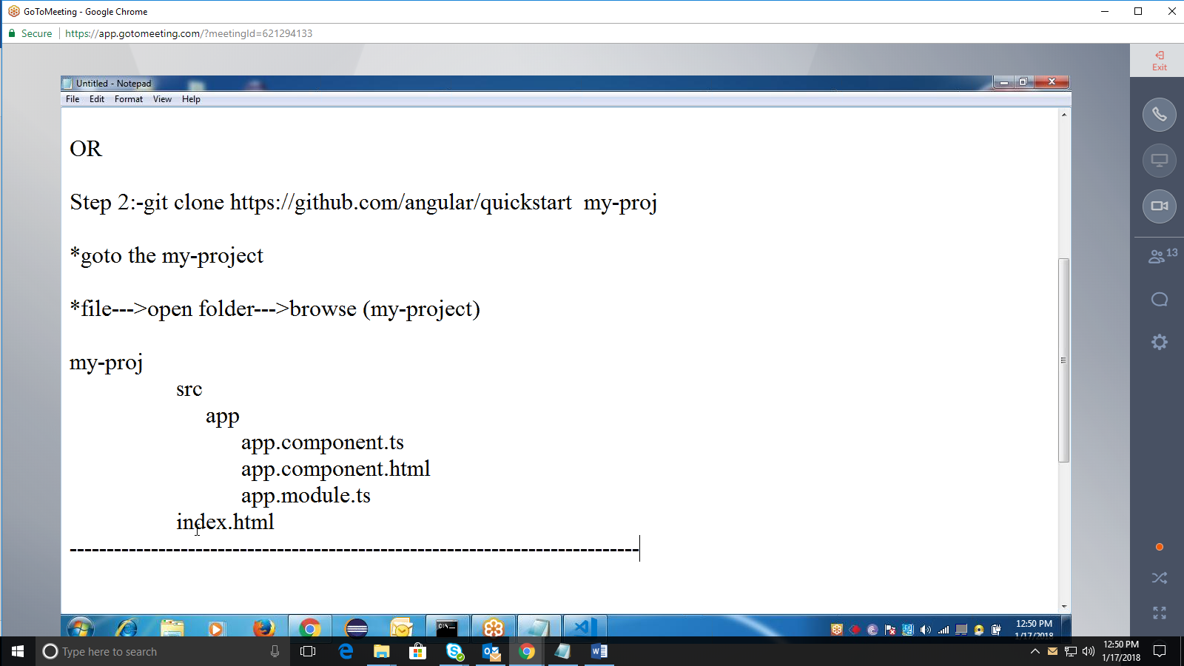

Ts🡪tyspe script—scripting language

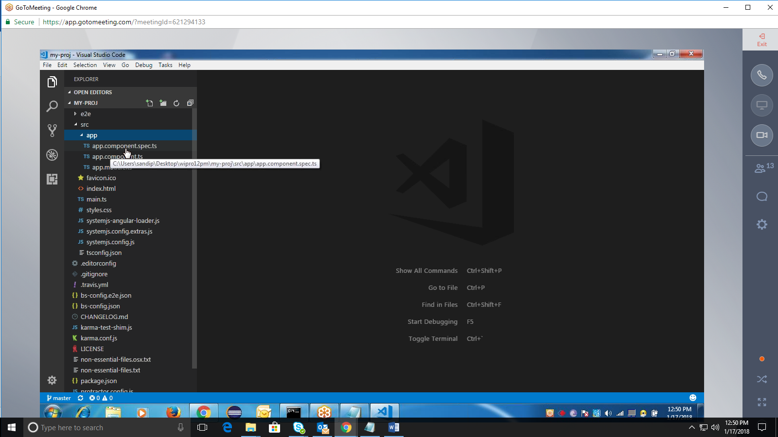

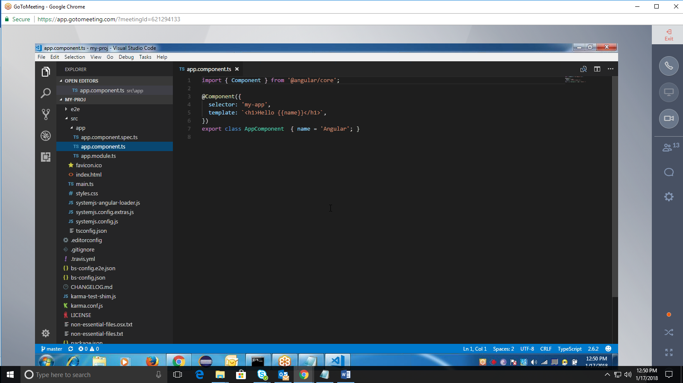

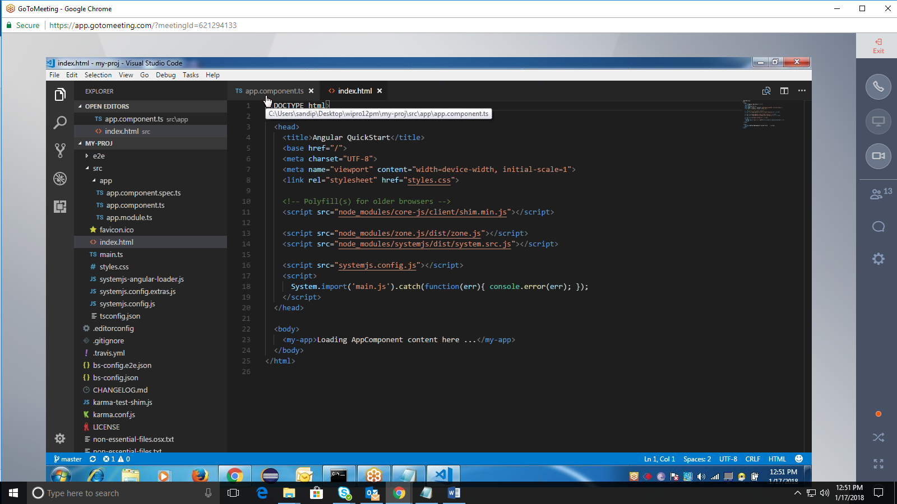

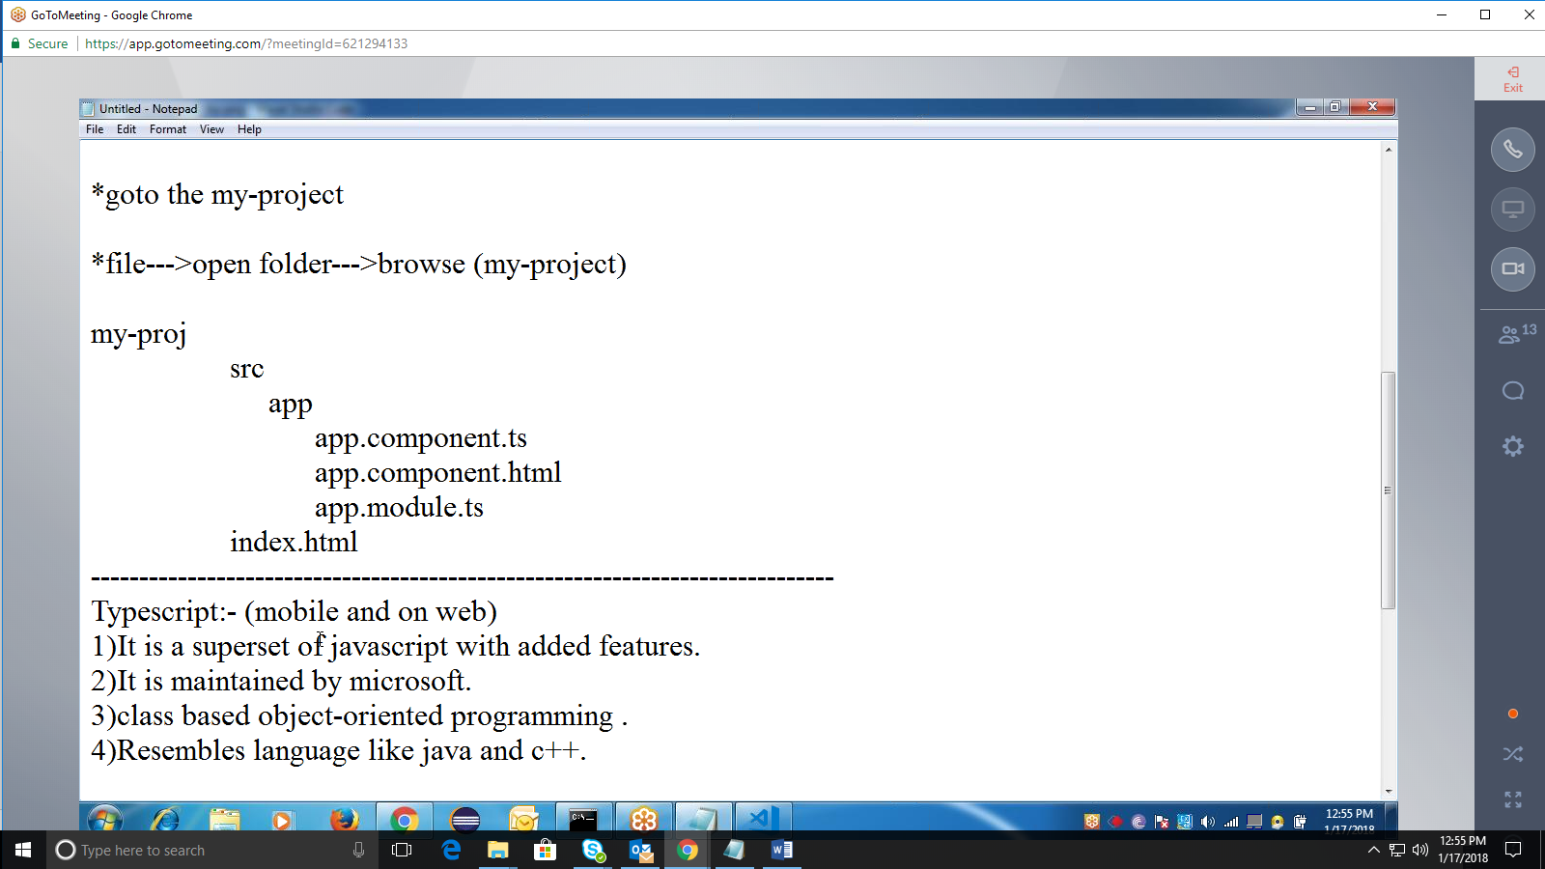

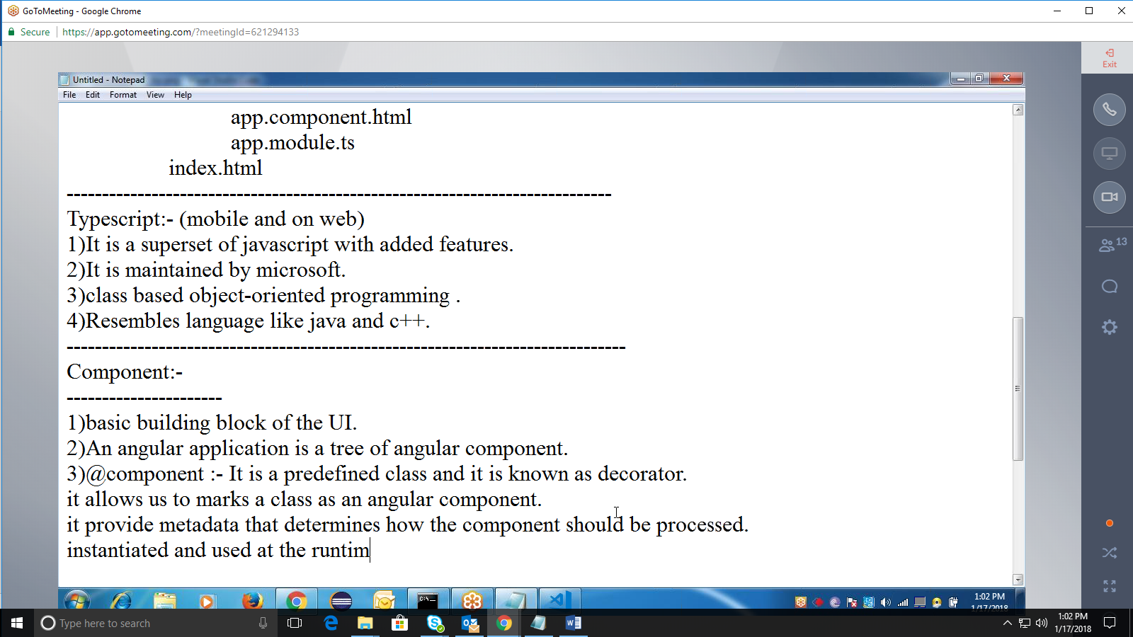

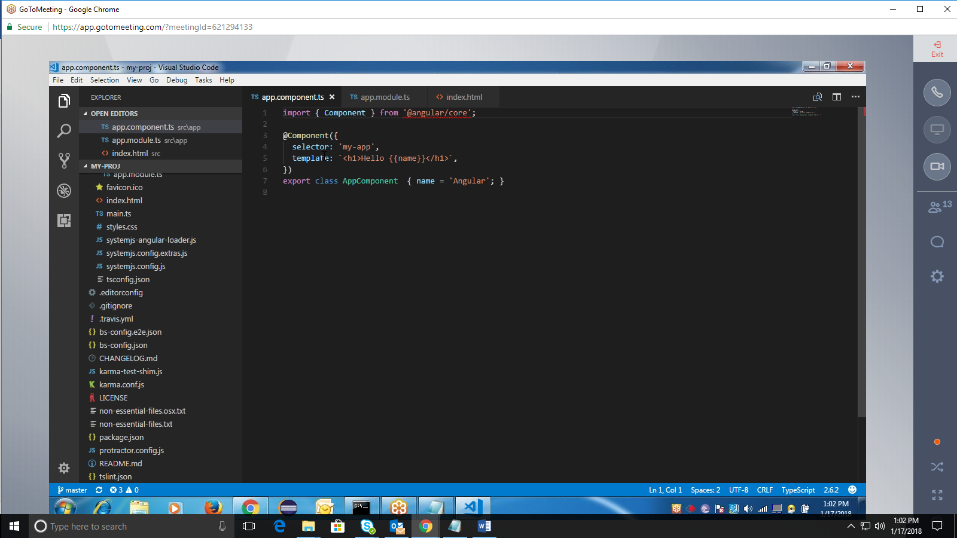

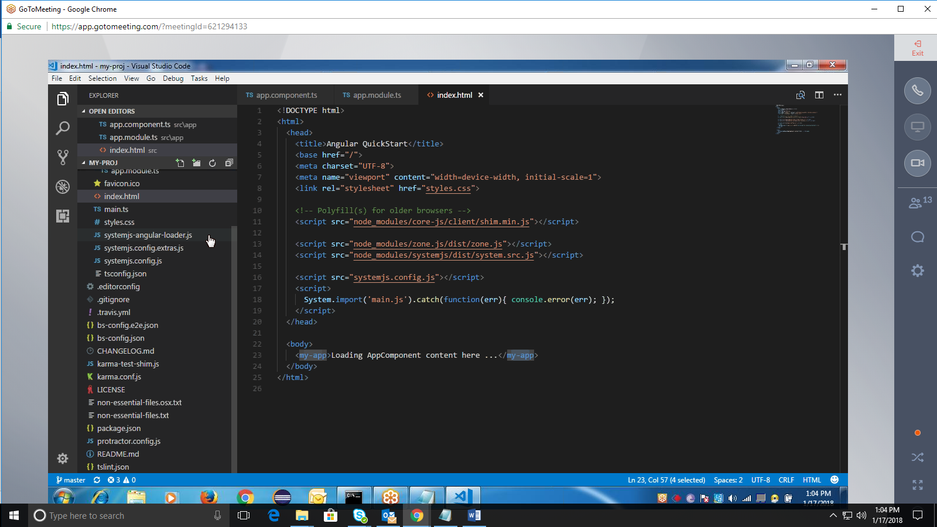

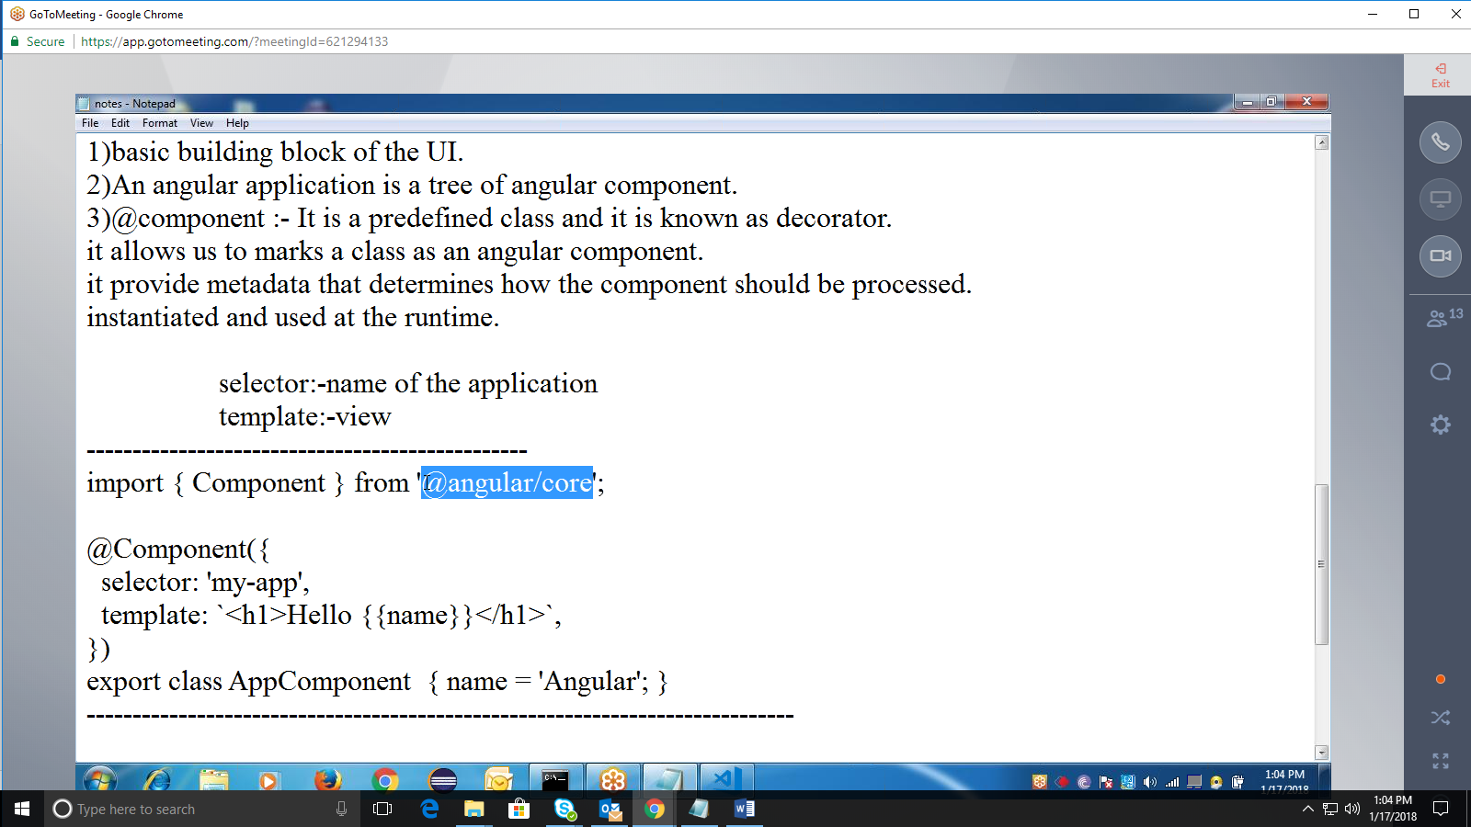

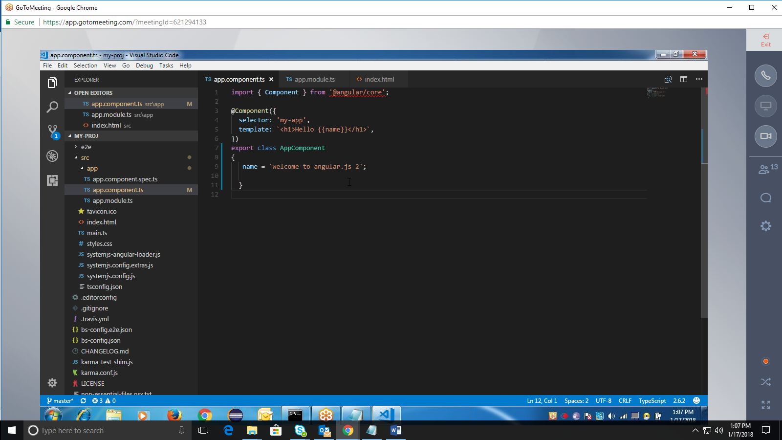

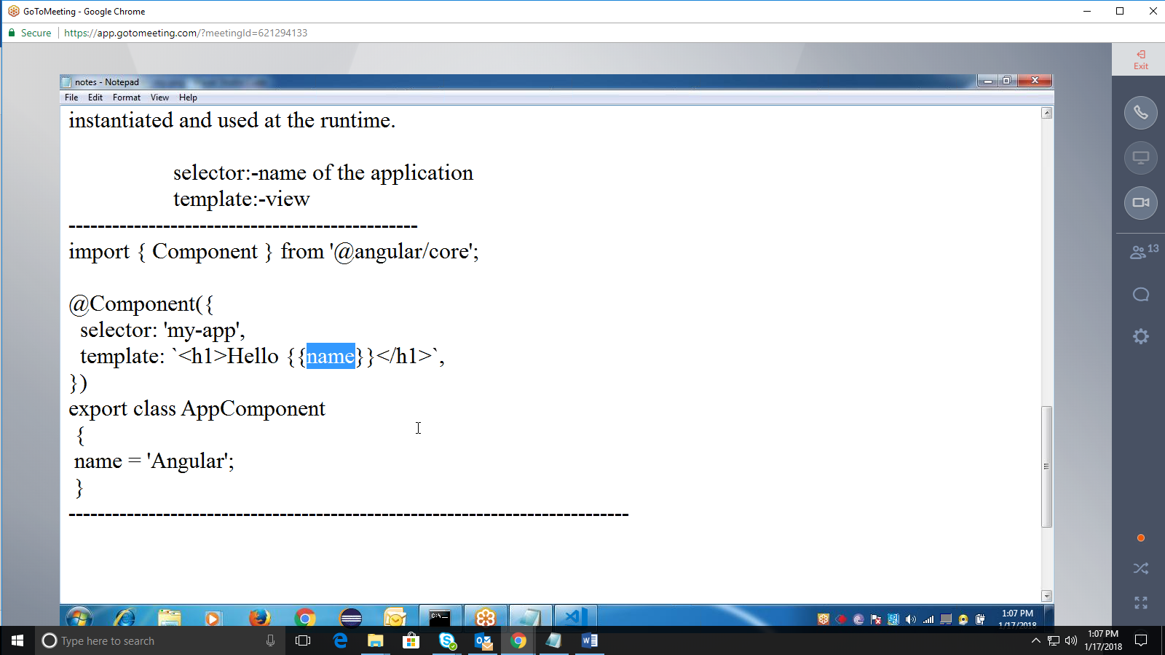

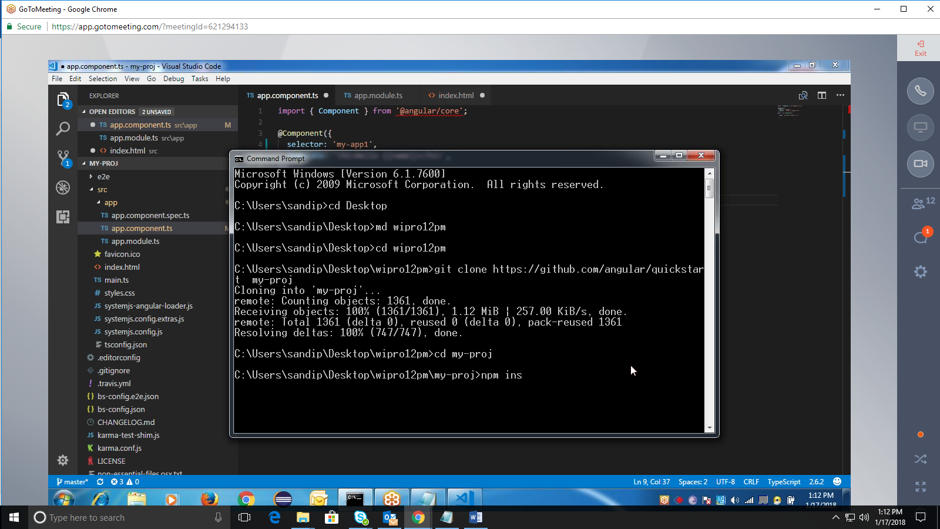

Npm: node packaging manager🡪

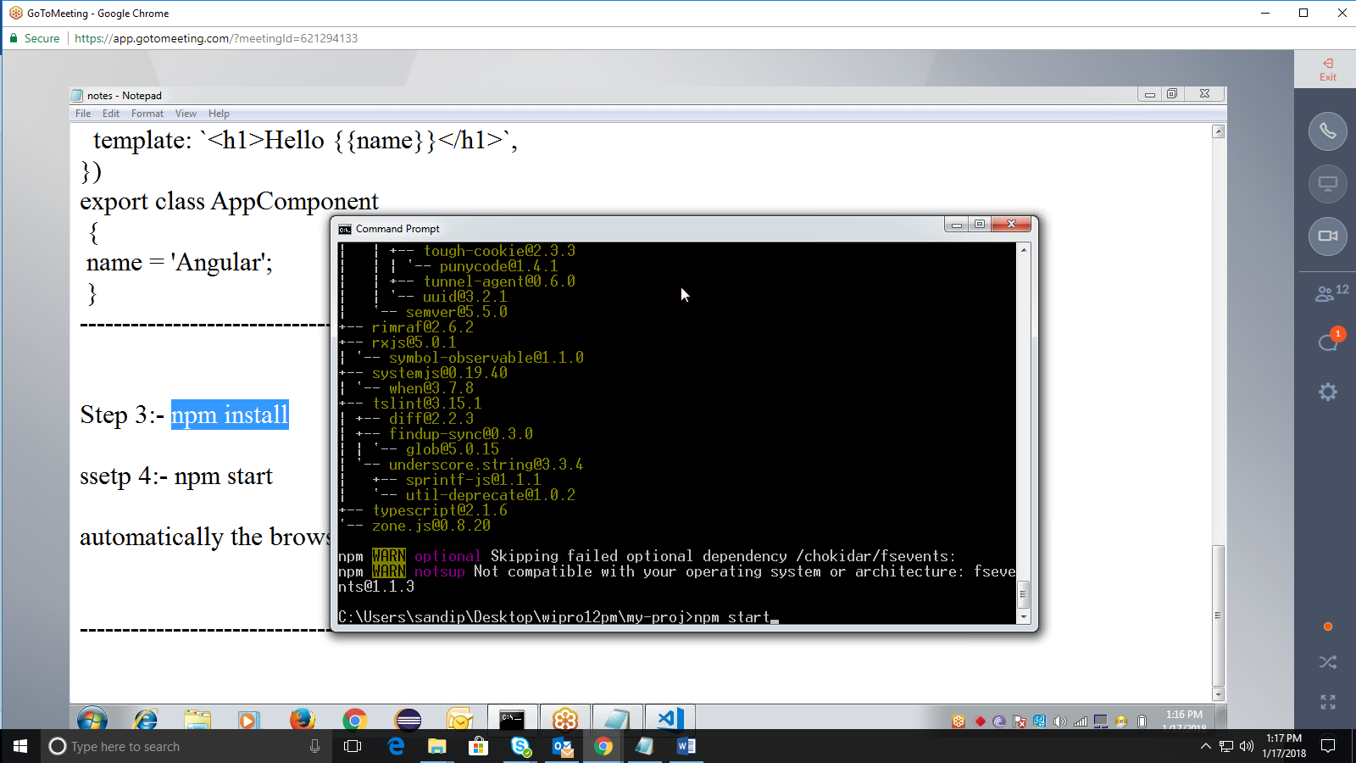

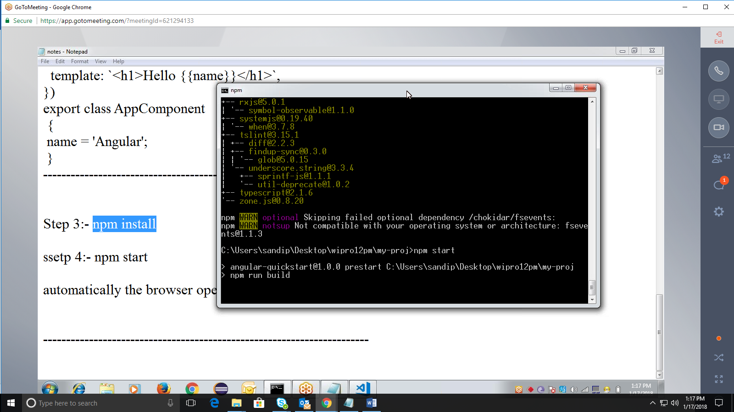

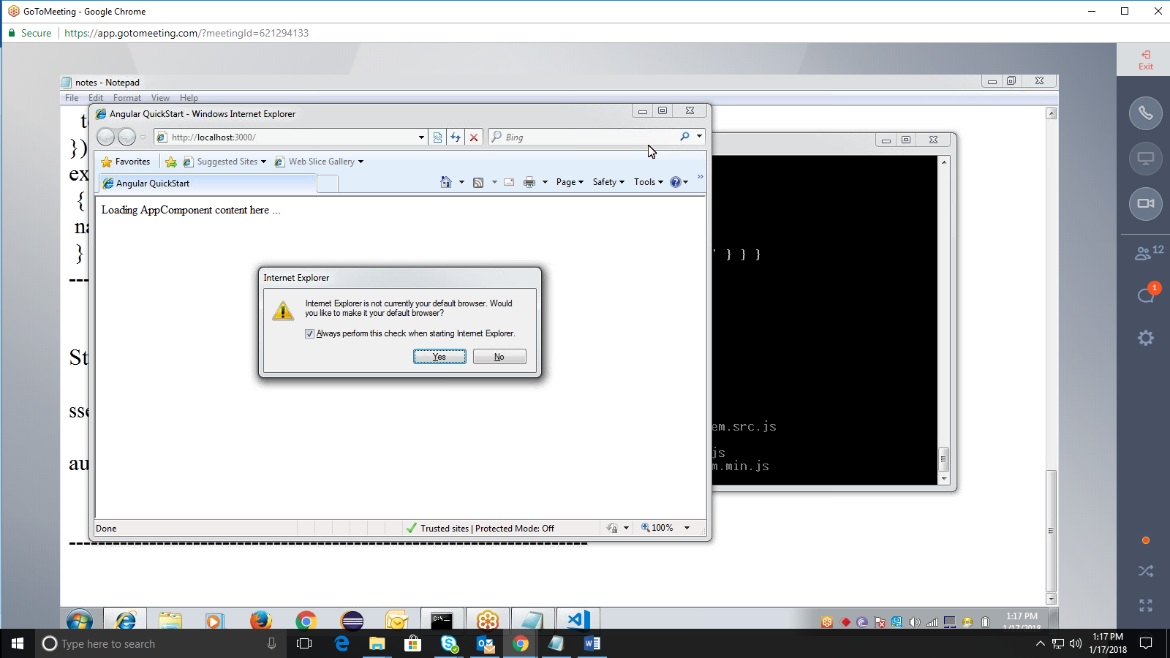

Server starts & browser opens

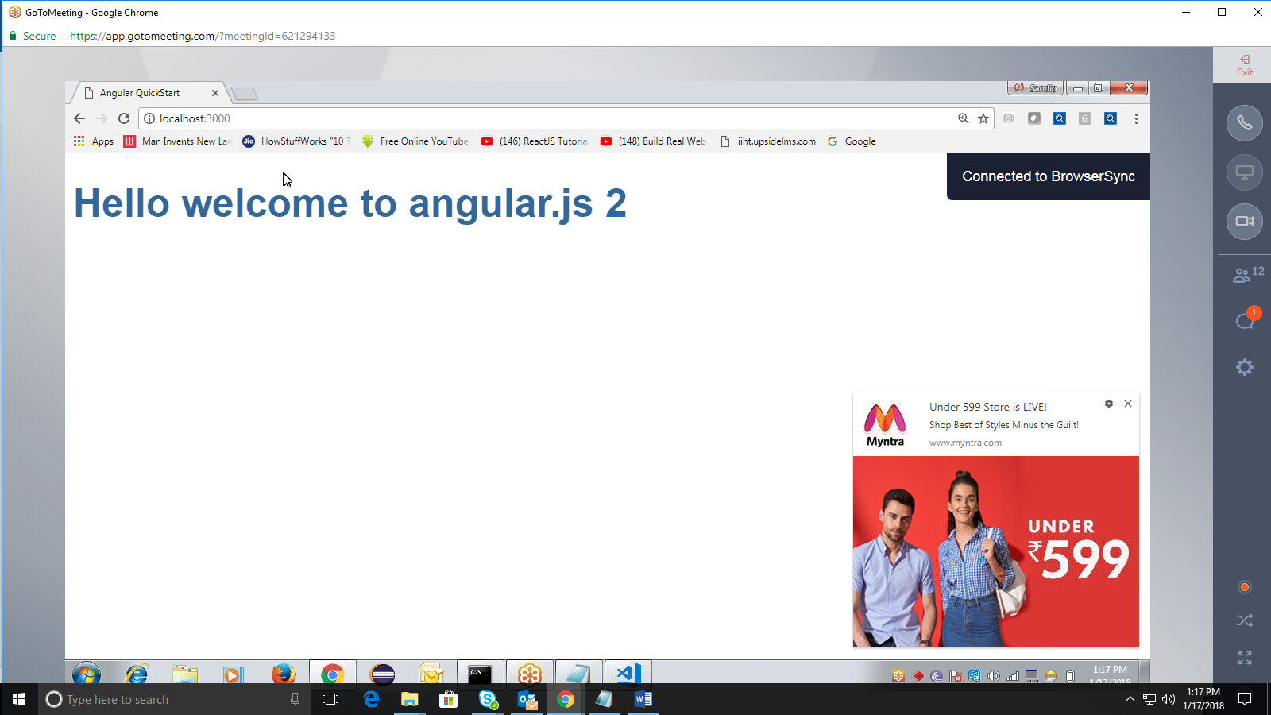

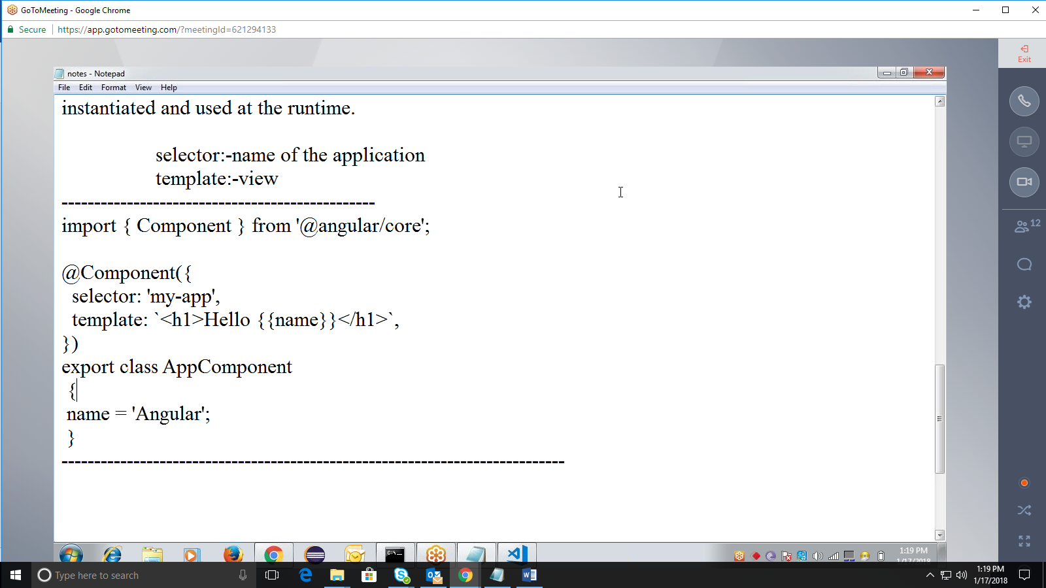

how the component should be processed.  
instantiated and used at the runtime.

selector:-name of the application template:-view

import { Component } from '@angular/core';

@Component({  
selector: 'my-app',  
template: &lt;h1>Hello {{name}}&lt;/h1>,  
})  
export class AppComponent  
{  
name = 'Angular';

}

Step 3:- npm install

ssetp 4:- npm start

automatically the browser opens :- [http://localhost:3000](http://localhost:3000/)

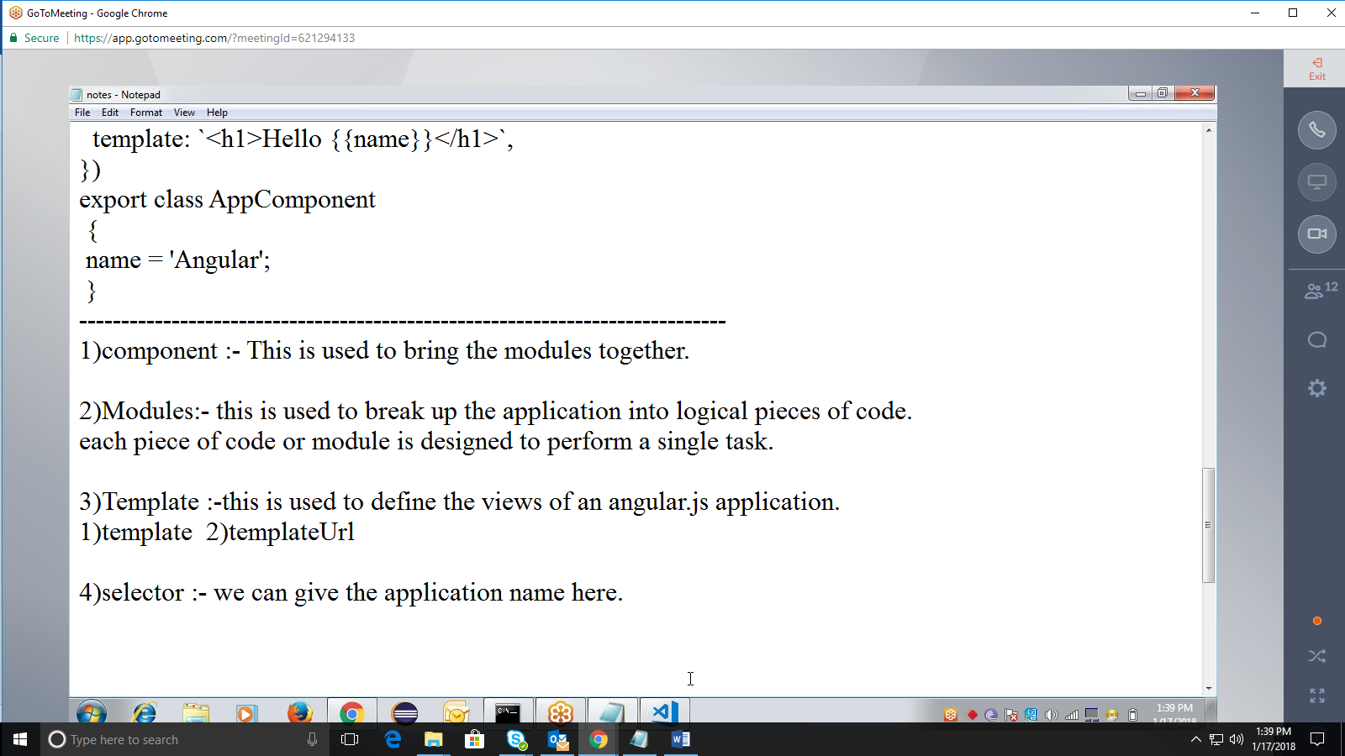

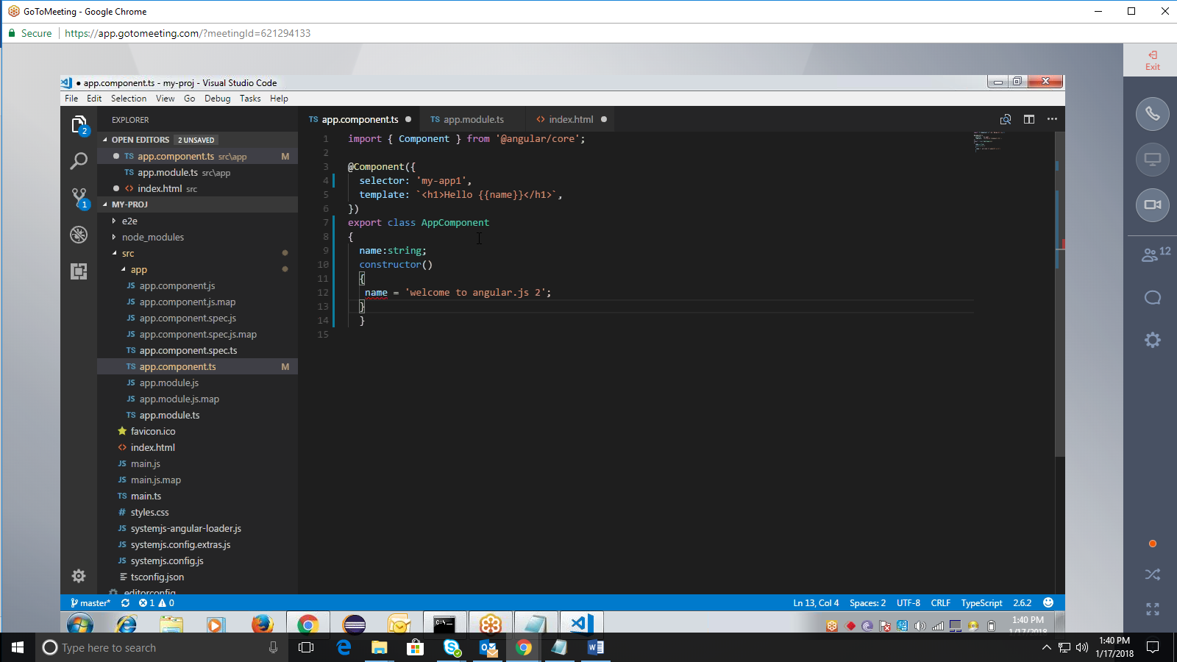

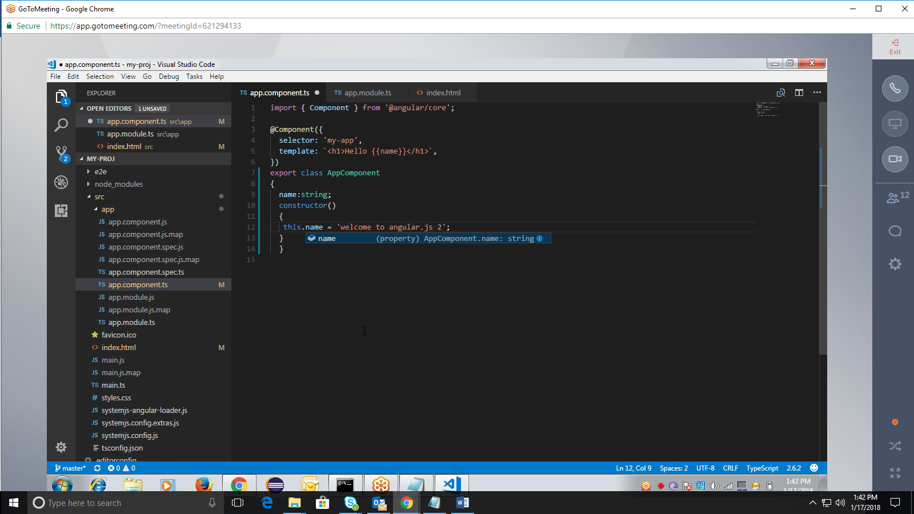

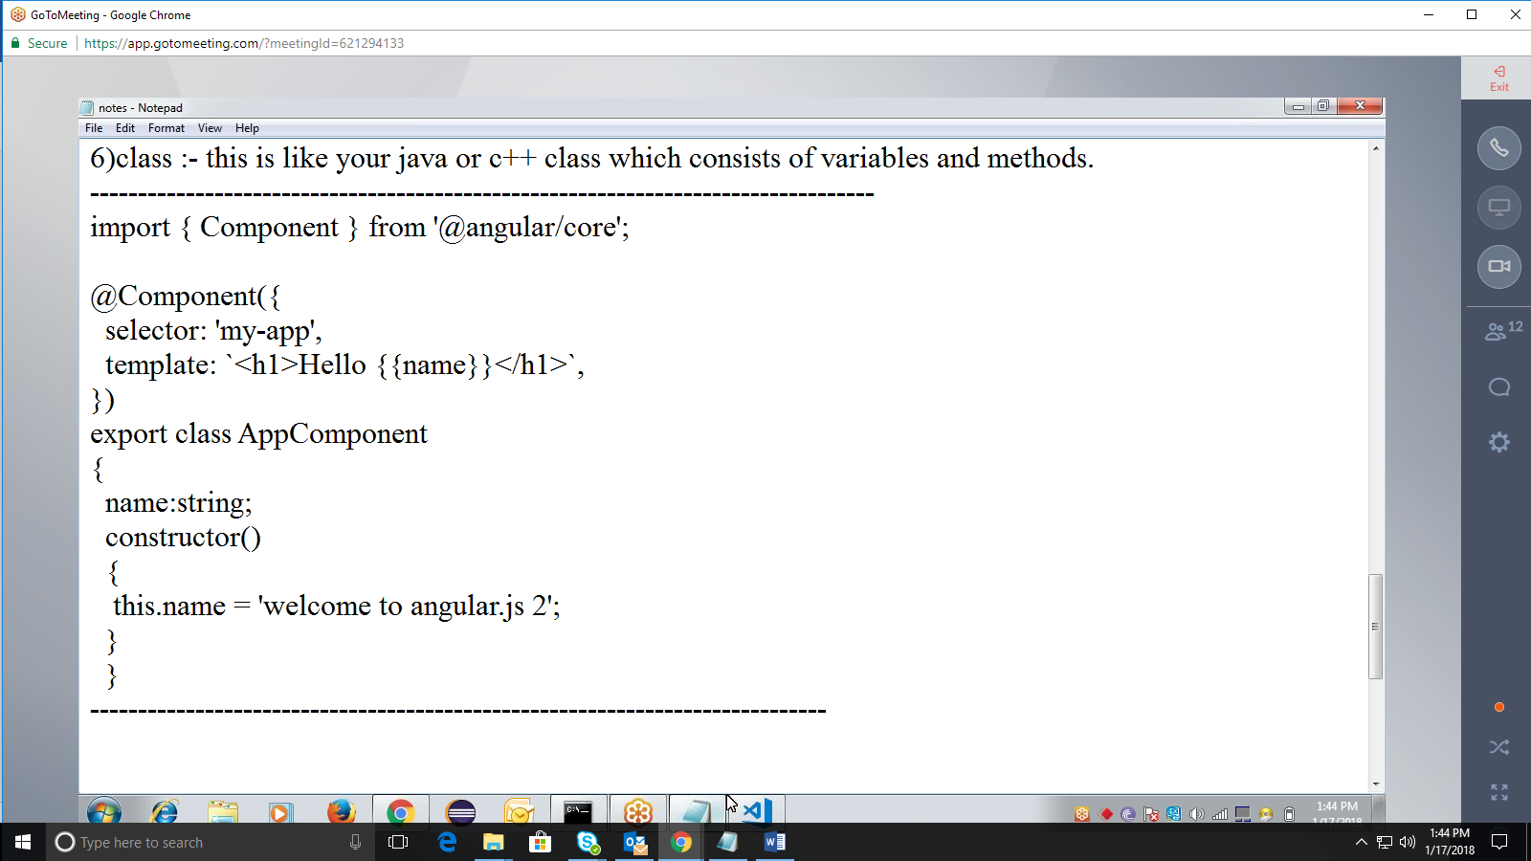

1)component :- This is used to bring the modules together.

2)Modules:- this is used to break up the application into logical pieces of code.  
each piece of code or module is designed to perform a single task.

3)Template :-this is used to define the views of an angular.js application.  
1)template 2)templateUrl

4)selector :- we can give the application name here.

5)constructor() :- it is used to assign values.

6)class :- this is like your java or c++ class which consists of variables and methods.

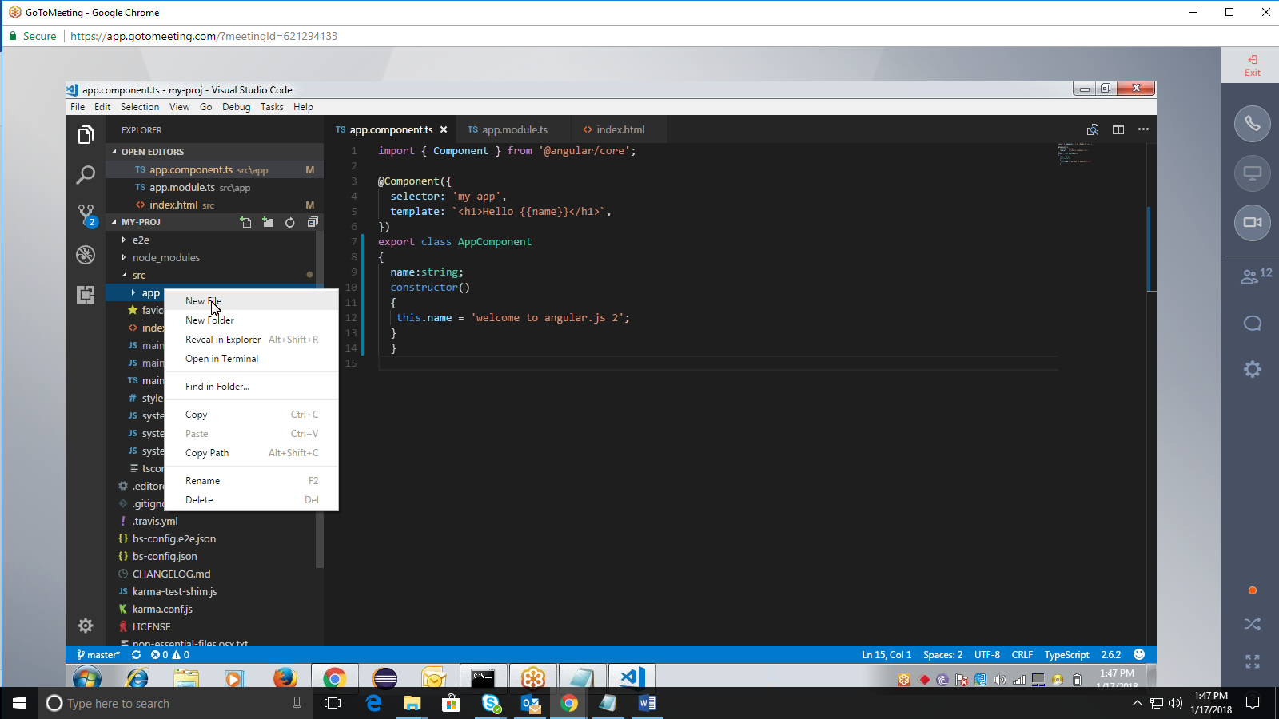

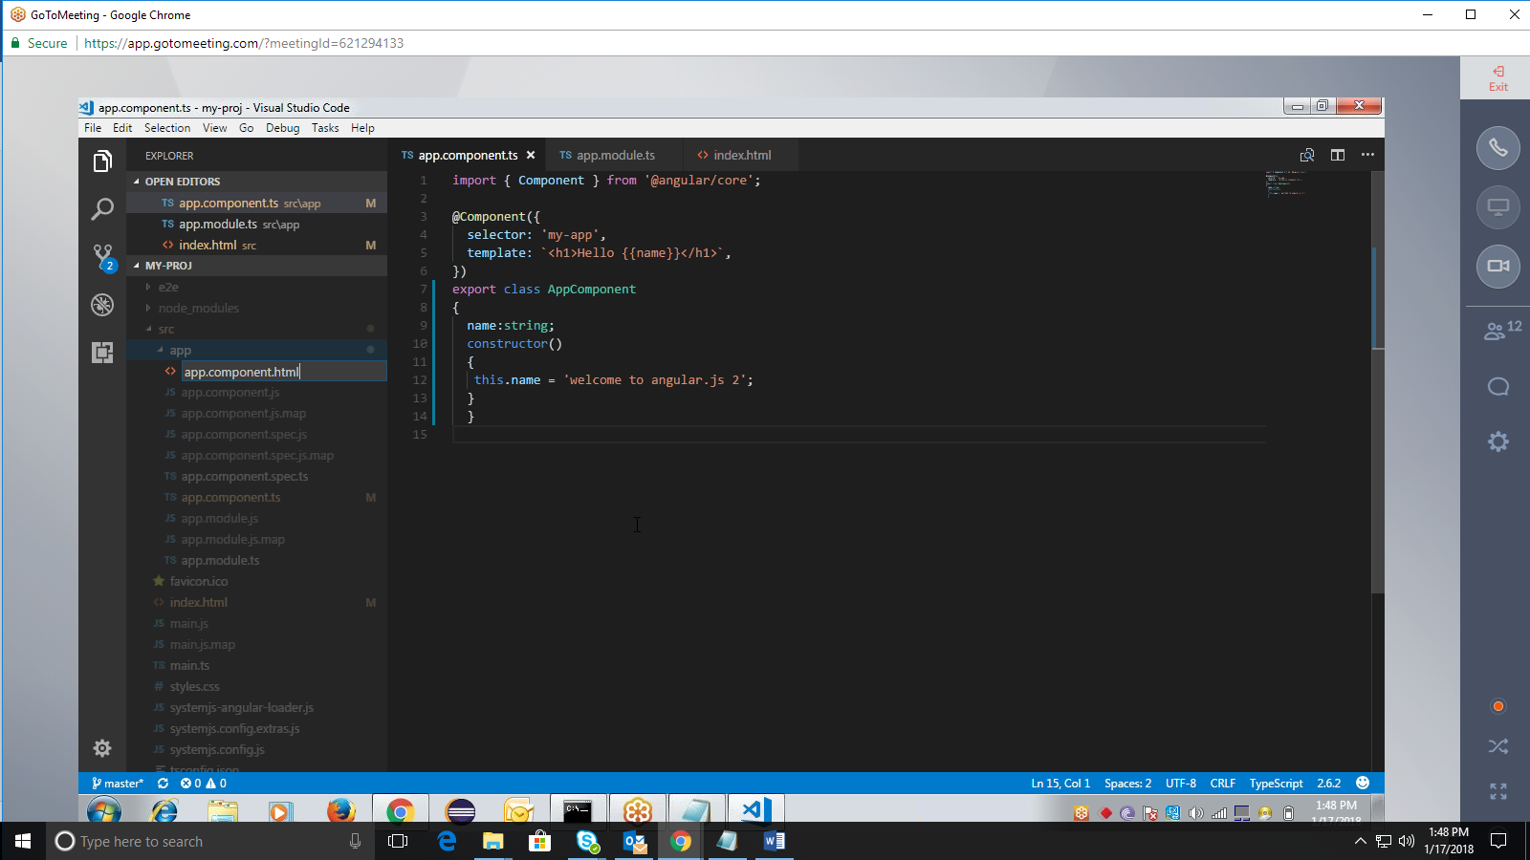

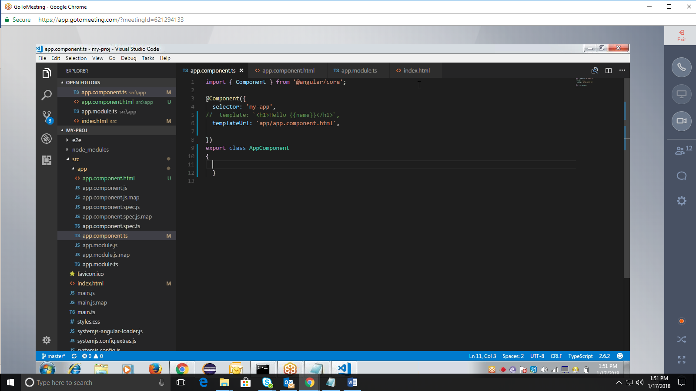

import { Component } from '@angular/core';

@Component({  
selector: 'my-app',  
templateUrl: app/app.component.html,  
})  
export class AppComponent  
{

## }

<html>  
<html>  
<body bgcolor=cyan>  
<form name="f1">  
<h2>EMPLOYEE REGISTRATION PAGE</h2>  
<hr color=blue>  
<table>  
<tr><td>Empno<td><input type="text" name=t1 size=20></tr>  
<tr><td>Name<td><input type="text" name=t2 size=20></tr>  
<tr><td>Address<td><input type="text" name=t3 size=20></tr>  
<tr><td>Phone no<td><input type="text" name=t4 size=20></tr>  
<tr><td><input type=submit value=submit></tr>  
</table>  
</form>  
</body>

## </html>

